29 September 2017
[26-17]

Supporting document 1

Safety Assessment Report – Application A1139

Food derived from Potato Lines F10, J3, W8, X17 & Y9

Executive summary

Background
Application A1139 seeks approval for the sale of food derived from genetically modified potatoes that have resistance to foliar late blight, reduced blackspot bruising and low acrylamide potential. Six potato lines have been generated using a two-step transformation process on three potato varieties. In the first step, E56 (SPS-ØØE56-7), F10 (SPS-ØØF10-7) and J3 (SPS-ØØØJ3-4) were generated from the transformation of Russet Burbank, Ranger Russet and Atlantic varieties respectively. These lines have reduced blackspot bruising and reduced acrylamide potential. In the second step, E56, F10 and J3 were retransformed, generating W8 (SPS-ØØØW8-4), X17 (SPS-ØØX17-5) and Y9 (SPS-ØØØY9-7) respectively. The second generation lines are resistant to foliar late blight and exhibit further reduction of acrylamide potential.

RNA interference (RNAi) was used to suppress the expression of genes associated with:

- conversion of storage carbohydrates such as starch and sucrose into the reducing sugars, glucose and fructose (phosphorylase L, water dikinase R1 and vacuolar invertase)
- regulating the levels of the amino acid asparagine (asparagine synthetase) and
- enzymatic browning, which in potatoes is referred to as blackspot bruising (polyphenol oxidase 5).

Decreasing the amount of reducing sugars and asparagine in the tubers will lead to lower amounts of acrylamide formation when the potatoes are cooked at temperatures used to prepare fries and chips. Minimising acrylamide in food is desirable because acrylamide has been shown to be a carcinogen in laboratory animals. The main reason for reducing blackspot bruising, which occurs during harvesting, packing and cutting, is to prevent unnecessary food wastage. To achieve RNAi-driven gene suppression, DNA derived from the crop potato Solanum tuberosum Ranger Russet and a related wild potato species S. verrucosum was introduced by agrobacterium-mediated transformation.

A further modification involved the introduction of the Rpi-vnt1 gene to provide protection against foliar late blight, a fungal disease that caused the Great Potato Famine in Ireland. The DNA, which includes the native sequences covering the promoter, Rpi-vnt1 gene and terminator, was derived from the related species S. venturii. The resulting novel protein does not have a pesticidal mode of action. Instead, this protein mediates the plants immune response to the pathogen.

This safety assessment addresses only food safety and nutritional issues of the GM food per se. It therefore does not address:

- environmental risks related to the environmental release of GM plants used in food production
- the safety of animal feed, or animals fed with feed, derived from GM plants
- the safety of food derived from the non-GM (conventional) plant.

History of use
On a global scale, potato is the fourth most important food crop following maize, rice and wheat and is cultivated in over 100 countries. It has been cultivated for human consumption for thousands of years and has a long history of safe use as human food. Potatoes are typically cooked before consumption and are processed into food commodities such as potato crisps, pre-cooked French fries, potato flour and potato starch. Potato is also used as a feed for domestic livestock and for the production of alcohol.

Molecular characterisation
The salient points from the molecular characterisation of potato lines W8, X17 and Y9 and the progenitor lines E56, F10 and J3 can be summarised as follows:

- Comprehensive molecular analyses indicate that a single insertion has occurred with each transformation step and each location has been identified.

- In every potato line, a fully intact insert containing the expression cassettes has been integrated and except for F10 and X17, additional rearranged elements of these cassettes have been identified flanking the main insert.

- Molecular studies have confirmed that only the required sequences have been inserted into the modified potatoes. No antibiotic resistance genes or other plasmid backbone sequences are present.

- As commercial potatoes are vegetatively propagated, standard Mendelian segregation analysis could not be used to determine inheritance. However, results from DNA analyses of W8, X17 and Y9 plants generated from two successive rounds of clonal propagation have confirmed that the inserted DNA was stably incorporated.

- Analysis of mRNA, protein and non-protein analytes associated with the genes targeted by RNAi showed the potato lines had significantly decreased levels of asparagine. Reducing sugars were also decreased in W8, X17 and Y9. The differences between the modified lines and the parental strains were statistically significant but fell within the range of natural variation seen in a range of non-GM control tubers. Furthermore, acrylamide formation was significantly reduced when tubers were processed into French fries and cooked. Similarly, there was a significant reduction in the formation of blackspot bruising on cut tubers.

Characterisation and safety assessment of new substances
Newly expressed protein

The three second generation lines W8, X17 and Y9 express the VNT1 protein. A bioinformatic approach confirmed the expressed protein is unlikely to be allergenic or toxic and would be as susceptible to digestion as the vast majority of dietary proteins. Although protein characterisation studies were unable to be performed due to the intractability of the protein, expression of a gene transcript was confirmed in all lines.

The results from the transcript expression analysis showed high levels of the VNT1 protein in the foliage and only minimal levels in the tuber. Although the protein expression levels were low, field efficacy studies of lines W8, X17 and Y9 showed resistance to three common P. infestans strains, US-18, US-22, US-23 and partial resistance to US-24.

Double-stranded (ds)RNAs

There are no concerns regarding the safety of the dsRNA in W8, X17, Y9, E56, F10 and J3. The available data do not indicate the dsRNA expressed in these lines possesses different characteristics, or is likely to pose a greater risk, than other RNAi mediators naturally present in potato.

Compositional analyses
A detailed compositional analysis was performed on W8, X17, Y9, F10 and J3 to establish the nutritional adequacy of tubers produced from these lines and to characterise any unintended compositional change. Analyses were done of proximates, fibre, vitamins, minerals, total amino acids, free amino acids, sucrose, reducing sugars (fructose and glucose), and anti-nutrients (glycoalkaloids). These showed that, even with the intended changes to sucrose, reducing sugars and asparagine, the levels of all analytes fell within the natural variation found across the range of conventional potato lines used for human consumption. No conclusion could be reached in relation to line E56 (which is not intended for commercial release) as no compositional data was provided.

Conclusion
No potential public health and safety concerns have been identified in the assessment of lines F10, J3, W8, X17 and Y9. On the basis of the data provided in the present Application, and other available information, food derived from F10, J3, W8, X17 and Y9 is considered to be as safe for human consumption as food derived from conventional potato varieties.

The assessment of line E56 could not be completed as no compositional data were provided.

Table of contents
Executive summary i
Index of Figures 1
Index of Tables 1
List of abbreviations 2
1 Introduction 3
2 History of use 4
2.1 Host organism 4
2.2 Donor organisms 5
3 Molecular characterisation 6
3.1 Transformation Method 7
3.2 Detailed description of DNA to be introduced 11
3.3 Development of the potato lines from original transformants 17
3.4 Characterisation of the inserted DNA and site(s) of insertion 18
4 Characterisation and safety assessment of novel substances 29
4.1 Newly expressed protein 29
4.2 Newly expressed dsRNA 32
5 Compositional analysis 33
5.1 Study design and conduct for key components 34
5.2 Analyses of key components in tubers 35
5.4 Conclusions of the compositional analyses 41
6 Nutritional impact 42
7 References 43

Index of Figures
 | Title | Page
Figure 1 | Outline of the Maillard reaction | 3
Figure 2 | Plasmid maps of pSIM1278 and pSIM1678 | 8
Figure 3 | Flowchart showing the development and selection methodology for the creation of the E56, F10 and J3 lines | 9
Figure 4 | Flowchart showing the development and selection methodology for the creation of the W8, X17 and Y9 lines | 10
Figure 5 | Design of the T-DNA region in pSIM1278 | 11
Figure 6 | Design of the T-DNA region in pSIM1678 | 15
Figure 7 | Generations of potato derived from vegetative propagation | 17
Figure 8 | A representation of the restriction enzyme map and probe binding sites of the inserted T-DNA regions | 20
Figure 9 | A map of the structure of the pSIM1278 T-DNA insert in W8 and E56 | 21
Figure 10 | A map of the structure of the pSIM1278 T-DNA insert in J3 and Y9 | 23
Figure 11 | A map of the structure of the pSIM1678 T-DNA insert in Y9 | 23
Figure 12 | The interrelationship between asparagine and glutamine biosynthesis pathways | 39

Index of Tables
 | Title | Page
Table 1 | Summary of the potato lines reviewed in this assessment | 3
Table 2 | Summary of the transformation steps used to create the potato lines | 7
Table 3 | The genetic elements contained in the T-DNA region of pSIM1278, used to create E56, F10 and J3 | 12-13
Table 4 | Description of the genetic elements contained in the backbone of pSIM1278 | 13-14
Table 5 | The genetic elements contained in the T-DNA region of pSIM1678, used to create W8, X17 and Y9 | 16
Table 6 | Molecular characterisation studies performed in W8 | 17
Table 7 | Molecular characterisation studies performed in X17 | 18
Table 8 | Molecular characterisation studies performed in Y9 | 18
Table 9 | Number of ORFs identified in W8, X17 and Y9 | 24
Table 10 | The change in asparagine levels in the transformed lines compared to the parental controls | 26
Table 11 | The change in sucrose and reducing sugar levels between transformed lines and parental controls in freshly harvested or 6 month cold-stored potatoes | 27
Table 12 | Percent change of acrylamide levels between transformed lines and parental controls in fries prepared from freshly harvested or 6 month cold-stored potatoes | 28
Table 13 | Field trial information for the F10, J3, W8, X17 and Y9 lines | 34
Table 14 | Analytes measured in the potato samples | 35
Table 15 | Summary of results from the compositional analyses | 37
Table 16 | Summary of total amino acids in the transformed lines | 38
Table 17 | Summary of total asparagine and glutamine levels in the transformed lines | 38
Table 18 | Summary of free asparagine and glutamine results | 40
Table 19 | Summary of the sucrose and reducing sugar levels in freshly harvested and cold-stored potatoes | 41

List of abbreviations
Asn1 | asparagine synthetase-1 gene
BLAST | basic local alignment search tool
BLASTP | basic local alignment search tool for proteins
bp | base pairs
DNA | deoxyribonucleic acid
FARRP | Food Allergy Research and Resource Program
FASTA | Fast alignment search tool - all
FDA | U.S. Food and Drug Administration
FAO | Food and Agriculture Organization of the United Nations
FSANZ | Food Standards Australia New Zealand
g | gram
GM | genetically modified
HPLC | High performance liquid chromatography
ipt | isopentenyl transferase gene
JECFA | Joint FAO/WHO Expert Committee on Food Additives
kb | kilobase
kDa | kilodalton
LB | left border of T-DNA (Agrobacterium tumefaciens)
mg | milligram
NCBI | National Centre for Biotechnology Information
NBY | nutrient broth-yeast
OECD | Organisation for Economic Co-operation and Development
ORF | open reading frame
pg | picogram
PhL | phosporylase-L gene
pAgp | ADP glucose pyrophosphorylase gene promoter
pGbss | granule-bound starch synthase promoter
Ppo5 | polyphenol oxidase-5 gene
PCR | polymerase chain reaction
R1 | water dikinase R1 gene
RB | right border of T-DNA (Agrobacterium tumefaciens)
PPO | polyphenol oxidase
dsRNA | double stranded RNA molecule
RNA | ribonucleic acid
RNAi | RNA interference
mRNA | messenger RNA molecule
Rpi-vnt1 | VNT1 gene
SAS | Statistical Analysis Software
SPS | Simplot Plant Science
ssDNA | single stranded DNA molecule
Code | Australia New Zealand Food Standards Code
T-DNA | transfer DNA
US | United States of America
VInv | vacuolar invertase gene
VNT1 | Late blight resistance protein

1 Introduction
FSANZ has received an Application from SPS International Inc (SPS), a subsidiary of J.R. Simplot Company (USA), to vary Schedule 26 in the Australia New Zealand Food Standards Code (the Code). The variation is to add food derived from six genetically modified (GM) potato lines from the Simplot Innate brand. These lines and their OECD Unique Identifiers are outlined in Table 1.

Table 1: Summary of the potato lines reviewed in this assessment
Parent variety | Russet Burbank | Ranger Russet | Atlantic
 | Transformation Step 1 (parent + plasmid pSIM1278)
Line | E56 | F10 | J3
OECD Unique Identifier | SPS-ØØE56-7 | SPS-ØØF10-7 | SPS-ØØØJ3-4
 | Transformation Step 2 (event 1 + plasmid pSIM1678)
Line | W8 | X17 | Y9
OECD Unique Identifier | SPS-ØØØW8-4 | SPS-ØØX17-5 | SPS-ØØØY9-7

Three potato lines (E56, F10 and J3) have been genetically modified using RNA interference (RNAi) to suppress the expression of four native potato genes. No new proteins are expressed and these lines are similar to line E12 that was assessed in Application A1128 (FSANZ 2016). The aims of the genetic modifications were to:

- reduce the production of acrylamide caused by cooking (frying, roasting and baking)
- reduce the incidence of black spot formation in raw tubers caused by bruising or cutting to enable a decrease in food wastage.

The genes targeted by RNAi to reduce the production of acrylamide during cooking include asparagine synthetase-1 (Asn1), water dikinase (R1) and phosphorylase-L (PhL). Acrylamide, a known carcinogen, has been shown to form in high carbohydrate-rich foods such as potatoes (Tareke et al. 2002), when they are fried, roasted or baked between 120-200°C (Rydberg et al. 2005). The acrylamide forms when the amino acid asparagine reacts with reducing sugars such as glucose and fructose (Figure 1), by the Maillard reaction (Stadler et al. 2002). By inhibiting the enzyme Asn1, there will be a reduction in the concentration of free asparagine in the potato. Combining this with the inhibition of R1 and PhL, which should lead to a reduction in the breakdown of starch into glucose, there will be a reduced potential for the derived food to produce acrylamide when cooked above 120°C.
NH₂
C=O
CH₂
NH₂-CH-COOH
asparagine
O
C
R R′

+
→
carbonyl group from glucose or fructose
NH₂
C=O
CH
CH₂
acrylamide

Figure 1: Outline of the Maillard reaction. The amino acid asparagine reacts with the carbonyl group found in glucose or fructose to produce acrylamide.

The gene targeted by RNAi to reduce black spot formation is polyphenol oxidase-5 (Ppo5). The PPO enzyme converts colourless polyphenols in the plant tissue to coloured quinones, which further react to produce dark melanin pigments. This discoloration results in reduced organoleptic properties, associated with increased food wastage.

A second transformation was carried out on E56, F10 and J3 to produce lines W8, X17 and Y9 respectively. The aims of the second round of transformations were to: (i) reduce sucrose hydrolysis leading to less reducing sugars thus further decreasing the acrylamide potential of the potato; and (ii) protect the plant from infection by the same late blight fungus (Phytophthora infestans) that was responsible for the Great Potato Famine in Ireland in the 1840’s.

In order to further reduce the acrylamide potential of the potato, RNAi was used to target the gene for vacuolar invertase (VInv). The expressed invertase converts stored sucrose into glucose and fructose, particularly on the outer edge of the potatoes, which has been associated with darkening on the ends of French fries and crisps (Zhu et al. 2014). The activity of this enzyme also increases with decreasing temperature, leading to an increase in reducing sugar formation at the cold temperatures normally used for storage of potatoes (Bhaskar et al. 2010; Sowokinos 2001). The gene added for protection against late blight is the late blight resistance gene (Rpi-vnt1) from the related potato species Solanum venturii. The resulting VNT1 resistance protein allows the plant to detect the presence of the infecting organism P. infestans, leading to the induction of the plant’s immune response and elimination of the fungus. This novel protein does not have a pesticidal mode of action.

The main objective of the application is to obtain food safety approval for trade purposes, as the Applicant has indicated none of these potato lines are currently intended to be grown in Australia or New Zealand but their processed products may enter the local food market through imports. At this stage, the initial lines (E56, F10 and J3) have limited food use and E56 in particular has not yet been commercialised. The second generation lines W8, X17 and Y9 are considered to have greater commercial potential.

2 History of use

2.1 Host organism
The information provided here is summarised from more detailed reports published by the Canadian Food Inspection Agency (CFIA 2015) and the Organisation for Economic Co-operation and Development (OECD 1997, 2002), with independent citations provided in the? text. Statistical data is from the FAOSTAT website managed by the Food and Agriculture Organization of the United Nations (FAO 2016).

The potato (Solanum tuberosum) originated from South America, where it has been cultivated for human consumption for thousands of years (Ugent and Peterson 1988). It is a perennial plant but is grown as an annual for commercial production. Potato is propagated vegetatively using small tubers or pieces of tuber typically referred to as seed or seed potatoes. However, vegetative propagation may perpetuate diseases. Thus, production of seed potato typically follows a certification system which includes starting with disease free stock, isolation from other potato production areas, control of disease-spreading insects and frequent inspection and culling of diseased plants. One disease, to which all three varieties of potato targeted by the Applicant are highly susceptible, is foliar late blight (SASA 2017).

Potato can also be propagated via sexually produced seed, contained within tomato-like berries. However, seed production and breeding are challenging. The species contains both diploid and tetraploid varieties which vary greatly with regard to self- and cross-compatibility. Pollen sterility occurs frequently and ovule sterility occurs occasionally within the species. Many varieties have been selected to not produce seed to minimise the resource requirements for seed production, thus increasing tuber yield. The degree, duration and response of flowering behaviour to environmental conditions are greatly influenced by the variety.

Internationally, potato is the fourth most important food crop following maize, rice and wheat and is cultivated in over 100 countries. Global potato production was estimated at over 385 million tonnes in 2014, with China the top producer at 96 million tonnes. In 2011, worldwide consumption of fresh and processed potatoes was about 35 kg/person/year with higher consumption in Australia and New Zealand at about 50 kg/person/year.

Potato is not a major crop in Australia and New Zealand, with production over the 10 years to 2014 averaging about 1.2 million tonnes and 0.5 million tonnes per year respectively. In 2013, Australia exported 52,000 tonnes and imported about 108,000 tonnes of potatoes and frozen potato products. In the same time period, New Zealand exported about 99,000 tonnes and imported about 14,500 tonnes of potato and processed potato products.

Whole potatoes are typically cooked before consumption or are processed into food commodities such as potato crisps, pre-cooked French fries and dehydrated potato products (diced, flaked or granules). Potato is also used for the production of industrial starch and alcohol, with the by-products and residues having the potential to be used to supplement animal feedstock.

The three varieties (Russet Burbank, Ranger Russet, Atlantic) chosen by the Applicant for genetic modification are predominantly used for the French fry market, with the Atlantic and Ranger Russet varieties also being highly suitable for crisps (SASA 2017). With their use in the French fry and crisp market, there is increased potential that acrylamide will be formed in the final potato products. All three varieties are also highly susceptible to foliar late blight infection, a current problem facing potato growers in North America. A genetic modification process was chosen to address these issues because Russet Burbank and Ranger Russet varieties are infertile, due to their inability to produce seed, and even though the Atlantic variety can produce seed, it has low fertility, therefore standard crossbreeding cannot be performed in these varieties.

Potato is not known to cause disease in humans or animals and has a long history of safe use as food. Potato and other members of the Solanaceae family, such as tomatoes and eggplants, naturally produce a pesticidal group of compounds called glycoalkaloids (GA), which can be toxic to humans if consumed in high quantities (greater than 1 mg GA per kg bodyweight). However, humans are rarely exposed to such high levels of the toxin. A maximum limit of 200 mg/kg fresh potato is the widely accepted safe limit for total GA in registered potato varieties. Proper storage conditions and peeling the potato before use help reduce levels of GA.

2.2 Donor organisms

2.2.1 Solanum tuberosum
The majority of the introduced DNA sequences in the two constructs used to transform the potatoes are derived from S. tuberosum, variety Ranger Russet. This commercial potato variety was commercially released by the USDA in 1991 (Potato Association of America), and thus has been in the food chain for 25 years. DNA sequences from this source include the ADP glucose pyrophosphorylase gene promoter (pAgp) and the granule-bound starch synthase promoter (pGbss), the Asn1, PhL, R1 and Vlnv gene fragments, some of the Left and Right Border region and spacer DNA sequences (see Tables 3 and 5 in Section 3.2). Intervening DNA sequences were also derived from S. tuberosum, variety unspecified.

2.2.2 Solanum verrucosum
The Ppo5 gene fragments were derived from S. verrucosum. This is a wild, edible species of potato from Mexico that has been used as a bridging species for the conventional breeding of desirable traits into the domesticated S. tuberosum potato.

2.2.3 Solanum venturii
The Rpi-vnt1 promoter, gene and termination sequence are derived from S. venturii. This is a wild species of potato with high resistance to foliar late blight, found in Argentina (Hawkes and Hjerting, 1960). The late blight resistance gene Rpi-vnt1 belongs to a family of resistance genes found in many plant species, including food crops like the potato (Marone et al. 2013; Xu et al. 2011). This diploid species would not produce viable offspring if bred with the tetraploid S. tuberosum varieties.

3 Molecular characterisation
Molecular characterisation is necessary to provide an understanding of the genetic material introduced into the host genome and helps to frame the subsequent parts of the safety assessment. The molecular characterisation addresses three main aspects:

- the transformation method together with a detailed description of the DNA sequences introduced to the host genome
- a characterisation of the inserted DNA, including any rearrangements that may have occurred as a consequence of the transformation
- the genetic stability of the inserted DNA and any accompanying expressed traits.

The Applicant has submitted the following unpublished studies for the molecular characterisation of lines W8, X17 and Y9. As the molecular characterisation includes analysis of both transformations, the characterisation is also applicable to the progenitor lines E56, F10 and J3.

Unpublished studies
- Copy number and structure for inserts in W8 Russet Burbank (2016) Report 15-35-SPS-MOL, SPS Regulatory Lab, Simplot Plant Sciences.
- The stability of pSIM1278 and pSIM1678 inserts in W8 (2016) Report 15-37-SPS-MOL, SPS Regulatory Lab, Simplot Plant Sciences.
- Characterization of insertion sites in Russet Burbank W8 (2016) Report 15-67-SPS-MOL, SPS Regulatory Lab, Simplot Plant Sciences.
- Expression of Rpi-vnt1 in W8 tuber and leaf tissues (2016) Report 15-70-SPS-MOL, SPS Regulatory Lab, Simplot Plant Sciences.
- Efficacy of polyphenol oxidase downregulation in W8 tubers (2015) Report 15-85-SPS-MOL, Simplot Plant Sciences.
- Allergen and toxin evaluation of open reading frames in Russet Burbank W8. Report (2016) 16-47-SPS-MOL, SPS Regulatory Lab, Simplot Plant Sciences.
- Molecular characterization of DNA inserts in Ranger Russet X17 (2016) Report 15-03-SPS-MOL, SPS Regulatory Lab, Simplot Plant Sciences.
- Characterization of the insertion site in Ranger Russet X17 (2016) Report 15-04-SPS-MOL, SPS Regulatory Lab, Simplot Plant Sciences.
- Assessment of insert stability in Ranger Russet X17 (2016) Report 15-06-SPS-MOL, SPS Regulatory Lab, Simplot Plant Sciences.
- Expression of Rpi-vnt1 in X17 tuber and leaf tissues (2016) Report 15-09-SPS-MOL, SPS Regulatory Lab, Simplot Plant Sciences.
- Efficacy of polyphenol oxidase downregulation in X17 tubers (2015) Report 15-95-SPS-MOL, Simplot Plant Sciences.
- Allergen and toxin evaluation of open reading frames in Ranger Russet X17 (2016) Report 16-48-SPS-MOL, SPS Regulatory Lab, Simplot Plant Sciences.
- Characterization of the insertion sites in Atlantic Y9 (2016) Report 15-12-SPS-MOL, SPS Regulatory Lab, Simplot Plant Sciences.
- Assessment of insert stability in Atlantic event Y9 (2016) Report 15-14-SPS-MOL, SPS Regulatory Lab, Simplot Plant Sciences.
- Expression of Rpi-vnt1 in Y9 tuber and leaf tissues (2016) Report 15-17-SPS-MOL, SPS Regulatory Lab, Simplot Plant Sciences.
- Efficacy of polyphenol oxidase downregulation in Y9 tubers (2015) Report 15-96-SPS-MOL, Simplot Plant Sciences.
- Allergen and toxin evaluation of open reading frames in Atlantic Y9 (2016) Report 16-49-SPS-MOL, SPS Regulatory Lab, Simplot Plant Sciences.

3.1 Transformation Method
In order to create the W8, X17 and Y9 lines, two distinct transformations were carried out as summarised in Table 2. The first transformation was used to create lines E56 (Russet Burbank), F10 (Ranger Russet) and J3 (Atlantic) and involved the plasmid pSIM1278 (Figure 2). The second transformation, using plasmid pSIM1678 (Figure 2) generated lines W8, X17 and Y9.

Table 2: Summary of the transformation steps used to create the potato lines
Event Number | Plasmids used for transformation | Variety
 |  | Russet Burbank | Ranger Russet | Atlantic
1 | pSIM1278 | E56 | F10 | J3
2 | Event 1 + pSIM1678 | W8 | X17 | Y9

Plasmid pSIM1278 was used to introduce DNA sequences for Asn1, R1, Ppo5 and PhL with the aim of silencing the expression of asparagine synthetase-1, water dikinase, phosphorylase-L and polyphenol oxidase-5 respectively. pSIM1678 introduced DNA sequences for Vlnv with the aim of suppressing the expression of vacuolar invertase, while adding the late blight resistance gene Rpi-vnt1 to protect the plant from foliar late blight infection.

The methodology used to establish and select the transformed potatoes has been previously published by SPS (Richael et al. 2008; Richael and Rommens 2012) and is outlined in the flowcharts presented in Figures 3 and 4. In summary, the transformation involved infection of plant tissue with a C58-derived strain of Agrobacterium AGL1, containing the plasmids pSIM1278 or pSIM1678. Plantlets were then grown on media containing the antibiotic timentin to suppress the growth of the agrobacterium. To identify transformants that had inadvertently taken up the plasmid backbone, explants that produced abnormal or stunted shoots indicative of expression of the ipt gene (in the backbone region) (see section 3.2.1) were discarded. The absence of backbone sequences was later confirmed by Southern blotting. In order to then identify transformants that had incorporated the T-DNA insert for further propagation, polymerase chain reaction (PCR) analysis was employed. Since potato is prone to somaclonal variation, several steps were taken during the propagation stages to identify and remove events with chromosomal rearrangements.

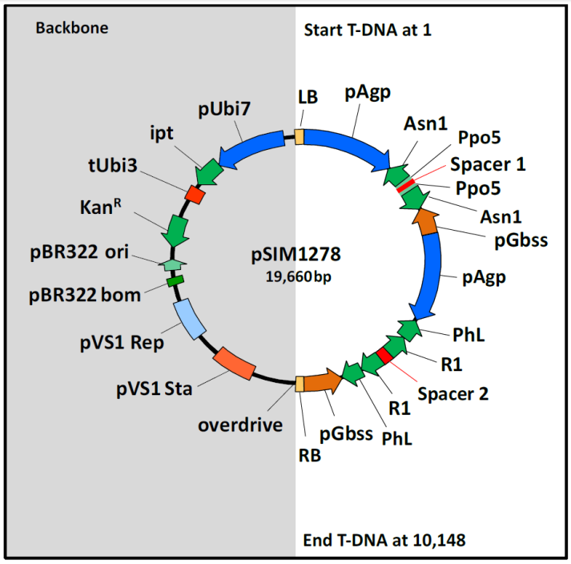
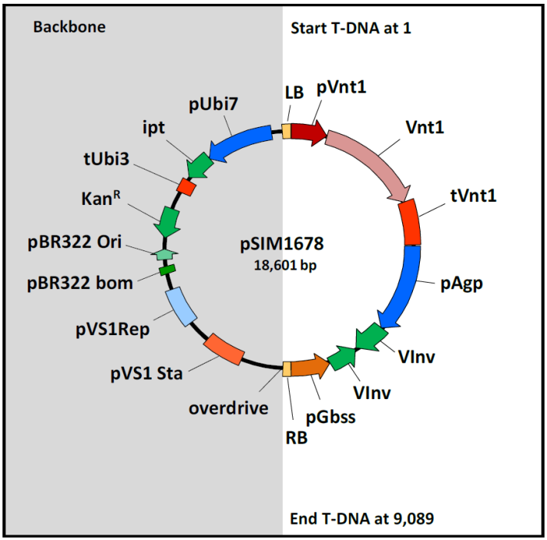

Figure 2: Plasmid maps of pSIM1278 and pSIM1678. Representation of the plasmids used to transform the three potato varieties. Both plasmids contain a T-DNA insert region that contains the DNA sequences of interest and are shown with a white background. The plasmid backbone region is shown with a grey background.

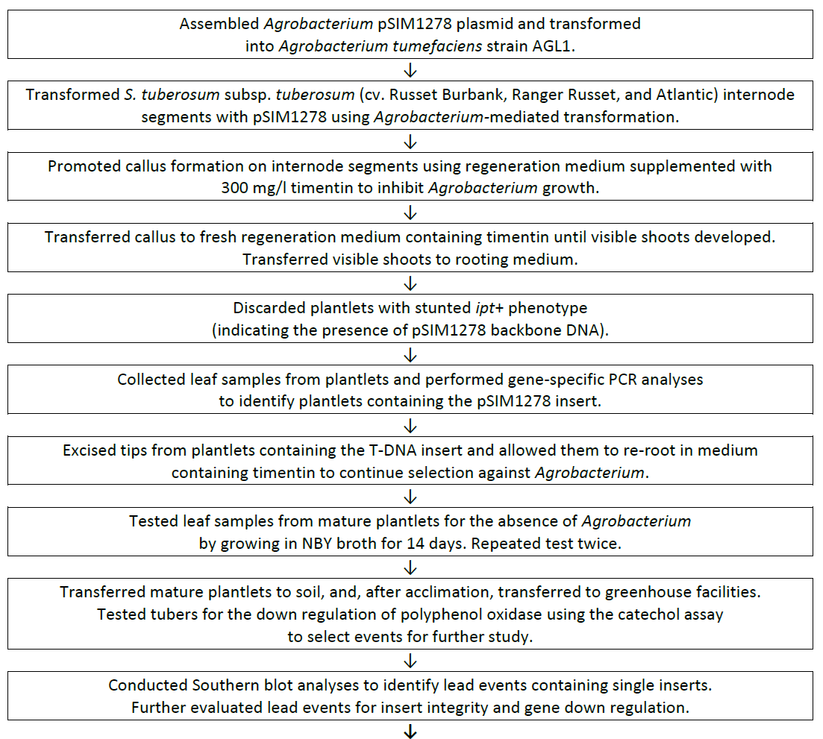

Figure 3: Flowchart showing the development and selection methodology for the creation of the E56, F10 and J3 lines
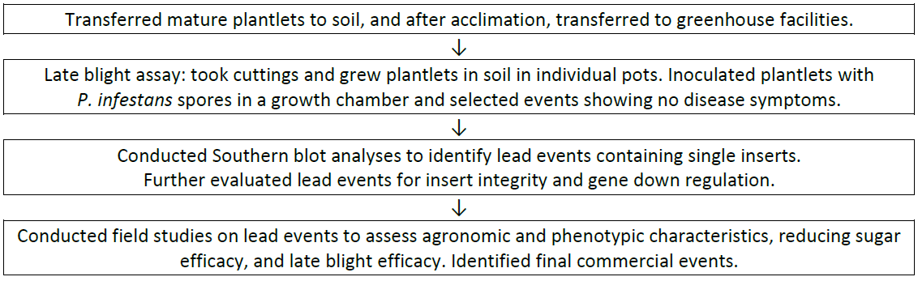
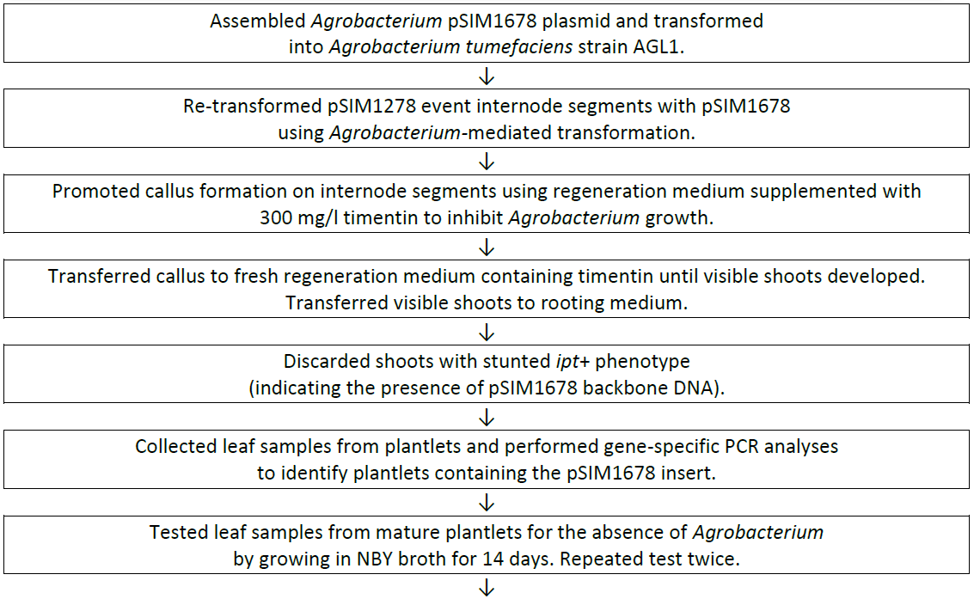

Figure 4: Flowchart showing the development and selection methodology for the creation of the W8, X17 and Y9 lines

3.2 Detailed description of DNA to be introduced
The sequential two-step transformation process described in Section 3.1 makes use of two distinct plasmids to generate the lines W8, X17 and Y9. Each plasmid is described below.

3.2.1 pSIM1278
FSANZ has previously described plasmid pSIM1278 in Application A1128 (FSANZ 2016). This plasmid was also used to generate the initial transformants E56, F10 and J3. A representation of the T-DNA region for pSIM1278, mapping the location of each of the genetic elements is shown in Figure 5 and a description of the genetic elements contained within pSIM1278 is presented in Tables 3 (T-DNA region) and 4 (backbone region). Only the DNA sequences in the T-DNA region are intended for incorporation into the potato genome.
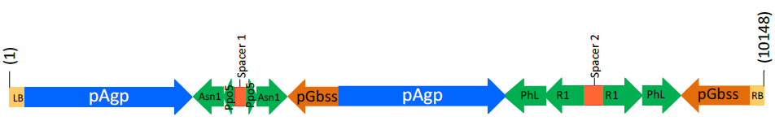
Asn/Ppo cassette
PhL/R1 cassette

Figure 5: Design of the T-DNA region in pSIM1278

The T-DNA region is encompassed by the left and right border regions, containing sequences to allow transfer of the T-DNA region from the plasmid into the plant genome, after the plasmid has been taken up by the potato cells. Within the T-DNA are two cassettes, each with inverted repeats from the four genes being targeted for down-regulation: Asn1, Ppo5, PhL and R1. The inverted repeats are made up of complementary sense and antisense sequences from the four gene fragments, located around a spacer region. After transcription, the complementary sequences come together, forming a double-stranded (ds) hairpin loop molecule known as dsRNA (Wesley et al. 2001). This dsRNA can then act as a precursor for the plants own RNAi regulatory pathway, supressing the translation of the targeted protein. The expression of these gene fragments is controlled by promoters from the ADP glucose pyrophosphorylase (Agp) gene and the granule-bound starch synthase (Gbss) gene. These promoters are highly active in tuber cells thus should allow high expression of the RNAi fragments in the tuber (Muller-Rober et al. 1994; Rommens et al. 2008; Visser et al. 1991).

The DNA contained within the backbone region of the plasmid is not intended for insertion into the potato genome. The sequences are required for preparing the plasmid, passaging through standard laboratory E. coli and into Agrobacterium and finally for ensuring entry into the plant cells. The majority of the sequences are from a parent plasmid known as pCAMBIA-1301. The sequence of pCAMBIA is publically available in GenBank. The Applicant has further modified pCAMBIA to include the isopentenyl transferase (ipt) gene, driven by a potato polyubiquitin promoter (Ubi7) and finishing with the terminator sequence from the potato ubiquitin-3 (tUbi3) gene (Forsyth et al. 2016; Richael et al. 2008). Expression of the ipt gene is used as a negative selection marker, as it allows identification and removal of plantlets that have incorporated the backbone region of the plasmid (Richael et al. 2008).
Table 3: The genetic elements contained in the T-DNA region of pSIM1278, used to create E56, F10 and J3
Genetic element | Relative position | Size (bp) | Source | Description, Function & Reference
Left border (LB) | 1 - 25 | 25 | Synthetic¹ | Secondary cleavage site. Releases ssDNA² insert from pSIM1278  (van Haaren et al. 1989)
Left border region | 26 - 187 | 162 | S. tuberosum  (var. Ranger Russet) | Supports secondary cleavage at LB and provides buffer for truncations
Intervening sequence | 188 - 193 | 6 | S. tuberosum | Sequence used for DNA cloning
Promoter for the Agp gene (pAgp)  1st copy | 194 -2,453 | 2260 | S. tuberosum  (var. Ranger Russet) | One of two convergent promoters driving expression of Asn1 and Ppo5 inverted repeats, especially in the tuber
Fragment of Asn1 gene  1st copy in antisense orientation | 2,454 - 2,858 | 405 | S. tuberosum  (var. Ranger Russet) | Binds to 2nd copy of Asn1 fragment to generate dsRNA³ that down regulates asparagine synthetase to impair asparagine formation (Chawla et al. 2012)⁴
3’-untranslated sequence of Ppo5 gene 1st copy in antisense orientation | 2,859 - 3,002 | 144 | S. verrucosum | Binds to 2nd copy of Ppo5 fragment to generate dsRNA that triggers the down regulation of polyphenol oxidase (PPO) to reduce black spot development
Intervening sequence | 3,003 – 3,008 | 6 | S. tuberosum | Sequence used for DNA cloning
Spacer-1 | 3.009 – 3,165 | 157 | S. tuberosum  (var. Ranger Russet) | Sequence between the antisense and sense inverted repeats of Asn1 and Ppo5: transcript forms loop in the dsRNA molecules
3’-untranslated sequence of Ppo5 gene 2nd copy in sense orientation | 3,166 – 3,309 | 144 | S. verrucosum | Binds to 1st copy of Ppo5 fragment to generate dsRNA that triggers the down regulation of PPO to reduce black spot development
Fragment of Asn1 gene  2nd copy in sense orientation | 3,310 – 3,715 | 406 | S. tuberosum  (var. Ranger Russet) | Binds to 1st copy of Asn1 fragment to generate dsRNA that down regulates asparagine synthetase to impair asparagine formation
Intervening sequence | 3,716 – 3,721 | 6 | S. tuberosum | Sequence used for DNA cloning
Promoter for the Gbss gene (pGbss)  1st copy | 3,722 – 4,407 | 686 | S. tuberosum  (var. Ranger Russet) | One of two convergent promoters driving expression of the inverted repeat fragments of Asn1 and Ppo5, especially in the tuber
Intervening sequence | 4,408 – 4,423 | 16 | S. tuberosum | Sequence used for DNA cloning
Promoter for the pAgo gene  2nd copy | 4,424 – 6,683 | 2260 | S. tuberosum  (var. Ranger Russet) | One of two convergent promoters driving expression of the inverted repeat fragments of PhL and R1, especially in the tuber
Fragment of PhL gene promoter (pPhL) 1st copy in antisense orientation | 6,684 – 7,192 | 509 | S. tuberosum  (var. Ranger Russet) | Binds to 2nd copy of PhL fragment to generate dsRNA that triggers the degradation of PhL transcripts to limit the formation of reducing sugars
Fragment of R1 gene promoter (pR1)  1st copy in antisense orientation | 7,193 – 7,724 | 532 | S. tuberosum  (var. Ranger Russet) | Binds to 2nd copy of RI fragment to generate dsRNA that triggers the degradation of R1 transcripts to limit the formation of reducing sugars
Intervening sequence | 7,725 – 7,730 | 6 | S. tuberosum | Sequence used for DNA cloning
Spacer-2 | 7,731 – 7,988 | 258 | S. tuberosum  (var. Ranger Russet) | Sequence between the antisense and sense inverted repeats of PhL and R1: transcript forms loop in the dsRNA molecules
Fragment of R1 gene promoter (pR1)  2nd copy in sense orientation | 7,989 – 8,520 | 532 | S. tuberosum  (var. Ranger Russet) | Binds to 1st copy of R1 fragment to generate dsRNA that triggers the degradation of R1 RNA to reduce levels of reducing sugars
Fragment of PhL gene promoter (pPhL)  2nd copy in sense orientation | 8,521 – 9,029 | 509 | S. tuberosum  (var. Ranger Russet) | Binds to 1st copy of PhL fragment to generate dsRNA that triggers the degradation of PhL RNA to reduce levels of reducing sugars
Promoter for the Gbss gene (pGbss)  2nd copy | 9,030 – 9,953 | 924 | S. tuberosum  (var. Ranger Russet) | One of the two convergent promoters driving expression of the inverted repeat fragments of PhL and R1
Intervening sequence | 9,954 – 9,962 | 9 | S. tuberosum | Sequence used for DNA cloning
Right border region | 9,963 – 10,123 | 161 | S. tuberosum (var. Ranger Russet) | Supports secondary cleavage at RB site and provides buffer for truncations
Right border (RB) | 10,124 -10,148 | 25 | Synthetic¹ | Secondary cleavage site used to release ssDNA insert from pSIM1278  (van Haaren et al. 1989)
¹The LB and RB sequences (25 bp each) were synthetically designed to be similar to and function like T-DNA borders from Agrobacterium tumefaciens.
²ssDNA: single stranded DNA molecule
³dsRNA: double stranded RNA molecule
⁴ASN1 is referred to as StAst1 in Chawla et al. (2012)

Table 4: Description of the genetic elements contained in the backbone of pSIM1278
Genetic element | Relative position | Size (bp) | Source | Description, Function & Reference
Intervening sequence | 10,149 – 10,154 | 6 | Synthetic | Sequence used for DNA cloning
Overdrive | 10,155 – 10,184 | 30 | A. tumefaciens  Ti-plasmid | Enhances cleavage of A. tumefaciens RB site¹
Intervening sequence | 10,185 – 11,266 | 1,082 | Pseudomonas fluorescens pVS1 | pVS1 backbone¹
pVS1 partitioning protein StaA  (pVS1 Sta) | 11,267 – 12,267 | 1,001 | P. fluorescens pVS1 | pVS1 stability in Agrobacterium¹
Intervening sequence | 12,268 – 12,860 | 593 | P. fluorescens pVS1 | pVS1 backbone¹
pVS1 replicon  (pVS1Rep) | 12,861 – 13,861 | 1001 | P. fluorescens pVS1 | pVS1 region for replication in Agrobacterium¹
Intervening sequence | 13,862 – 14,099 | 238 | P. fluorescens pVS1 | pVS1 backbone¹
Intervening sequence | 14,100 – 14,270 | 171 | pBR322 | pCambia-1301 backbone¹
pBR322 bom | 14,271 – 14,531 | 261 | pBR322 | pBR322 region for replication in E. coli¹
Intervening sequence | 14,532 – 14,670 | 139 | pBR322 | pCambia-1301 backbone¹
Origin of replication for pBR322  (pBR322 ori) | 14,671 – 14,951 | 281 | pBR322 | Bacterial origin of replication¹
Intervening sequence | 14,952 – 15,241 | 290 | pBR322 | pCambia-1301 backbone¹
Neomycin phosphotransferase II (nptII) gene | 15,242 – 16,036 | 795 | Tn5 transposon | Aminoglycoside phosphotransferase for kanamycin resistance; to selective positive bacterial transformants¹
Intervening sequence | 16,037 – 16,231 | 195 | Vector DNA | pCambia-1301backbone¹
Terminator of the ubiquitin-3 gene (tUbi3) | 16,232 – 16,586 | 355 | S. tuberosum | Terminator for ipt gene transcription
Intervening sequence | 16,587 – 16,937 | 351 | A. tumefaciens  Ti-plasmid | Sequence for DNA cloning
Isopentenyl transferase (ipt) gene | 16,938 – 17,660 | 723 | A. tumefaciens  Ti-plasmid | Allows for identification of plantlets that have incorporated the backbone DNA
Intervening sequence | 17,661 – 17,672 | 12 | Synthetic DNA | Sequence used for DNA cloning
Polyubiquitin promoter (Ubi7) | 17,673 – 19,410 | 1,738 | S. tuberosum  (var. Ranger Russet) | Promoter to drive expression of the ipt backbone marker gene
Intervening sequence | 19,411 – 19,660 | 250 | Vector DNA | pCambia-1301 backbone¹
¹pCAMBIA-1301 sequence as indicated by the blue shading is available @ http://www.ncbi.nlm.nih.gov/nuccore/AF234297.1

3.2.2 pSIM1678
The plasmid pSIM1678 was used to generate the W8, X17 and Y9 lines from their first transformation counterparts, E56, F10 and J3 respectively. A representation of the T-DNA region for pSIM1678, mapping the location of each of the genetic elements is shown in Figure 6 and a description of the genetic elements contained within the T-DNA region of pSIM1678 is presented in Table 5. The backbone region for this vector is the same as that
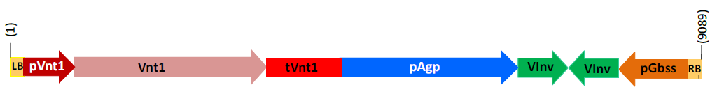
described for pSIM1278 (Section 3.2.1 and Table 4).
Rpi-nt1 cassette
Vlnv cassette

Figure 6: Design of the T-DNA region in pSIM1678

Similar to pSIM1278, the T-DNA region from pSIM1678 is encompassed by border regions containing sequences to allow transfer of the T-DNA region into the plant genome. Within the T-DNA is the late blight resistance gene cassette (Rpi-vnt1) under the control of the native gene promoter and terminator. Use of the native promoter ensures high expression of the protective protein in foliage (Gao and Bradeen 2016), where the disease occurs. Also contained within the T-DNA is the Vlnv RNAi cassette with inverted repeats from the Vlnv gene, located around a spacer region (not identified in Figure 6). The expression of the sense and antisense fragments are under the control of promoter sequences from the ADP glucose pyrophosphorylase (Agp) gene and the granule-bound starch synthase (Gbss) gene, which ensure that the RNAi sequences are highly expressed in the tuber (Muller-Rober et al. 1994; Rommens et al. 2008; Visser et al. 1991).
Table 5: The genetic elements contained in the T-DNA region of pSIM1678, used to create W8, X17 and Y9
Genetic element | Relative position | Size (bp) | Source | Description, Function & Reference
Left border (LB) | 1 - 25 | 25 | Synthetic¹ | Secondary cleavage site. Releases ssDNA² insert from pSIM1678  (van Haaren et al. 1989)
Left border region | 26 - 187 | 162 | S. tuberosum  (var. Ranger Russet) | Supports secondary cleavage at LB and provides buffer for truncations
Intervening sequence | 188 - 193 | 6 | S. tuberosum | Sequence used for DNA cloning
Native Rpi-vnt1 gene promoter | 194 - 902 | 709 | S. venturii | Drives expression of the Rpi-vnt1 gene, especially in the leaves
Rpi-vnt1 gene coding sequence | 903 - 3,578 | 2676 | S. venturii | Expresses the VNT1 protein for late blight protection
Native Rpi-vnt1 gene terminator | 3,579 - 4,503 | 925 | S. venturii | Terminates transcription of Rpi-vnt1
Intervening sequence | 4,504 - 4,510 | 7 | S. tuberosum | Sequence used for DNA cloning
Promoter for the Agp gene (pAgp) | 4,511 - 6,770 | 2260 | S. tuberosum  (var. Ranger Russet) | One of two convergent promoters driving expression of Vlnv inverted repeats, especially in the tuber
Intervening sequence | 6,771 - 6,776 | 6 | S. tuberosum | Sequence used for DNA cloning
Fragment of Vlnv gene in sense orientation | 6,777 - 7,274 | 498 | S. tuberosum  (var. Ranger Russet) | Binds to antisense fragment of Vlnv fragment to generate dsRNA³ that down regulates vacuolar invertase to impair reduced-sugar formation
Fragment of Vlnv gene in sense orientation | 7,275 - 7,455 | 181 | S. tuberosum  (var. Ranger Russet) | Spacer sequence between the inverted repeats; transcript forms loop in dsRNA
Intervening sequence | 7,456 - 7,461 | 6 | S. tuberosum | Sequence used for DNA cloning
Fragment of Vlnv gene in antisense orientation | 7,462 - 7,959 | 498 | S. tuberosum  (var. Ranger Russet) | Binds to sense fragment of Vlnv fragment to generate dsRNA that down regulates vacuolar invertase to impair reduced-sugar formation
Intervening sequence | 7,960 - 7,971 | 12 | S. tuberosum | Sequence used for DNA cloning
Promoter for the Gbss gene (pGbss) | 7,972 - 8,894 | 923 | S. tuberosum  (var. Ranger Russet) | One of the two convergent promoters driving expression of the inverted repeat fragments of Vlnv, especially in the tuber
Intervening sequence | 8,895 - 8,903 | 9 | S. tuberosum | Sequence used for DNA cloning
Right border region | 8,904 - 9,064 | 161 | S. tuberosum (var. Ranger Russet) | Supports cleavage at RB site and provides buffer for truncations
Right border (RB) | 9,065 - 9,089 | 25 | Synthetic¹ | Primary cleavage site used to release ssDNA insert from pSIM1278  (van Haaren et al. 1989)
¹The LB and RB sequences (25 bp each) were synthetically designed to be similar to and function like T-DNA borders from Agrobacterium tumefaciens.
²ssDNA: single stranded DNA molecule
³dsRNA: double stranded RNA molecule

3.3 Development of the potato lines from original transformants
After the transformation and selection process, plantlets were maintained in tissue culture or cultured in media to allow root formation. Plantlets with roots were transferred to soil or a hydroponic system in greenhouses to produce tubers. Tubers from greenhouse-grown potatoes were then replanted in the greenhouse or planted in fields, to generate multiple propagules. The use of the tuber or part thereof as a propagule is a characteristic of potato, allowing cultivation by vegetative propagation rather than by sexual reproduction. The progeny arising from this form of asexual reproduction will be genetically the same as the parent plant.

When characterising the three lines W8, X17 and Y9, different generations of plants were analysed. Plants and tubers arising from the initial planting of plantlets into soil are referred to as G0 and the plants and tubers arising from the planting of G0 tubers are referred to as G1 and so forth (Figure 7). The type of characterisations performed and at what generation they were analysed are summarised in Tables 6, 7 and 8 for lines W8, X17 and Y9 respectively.
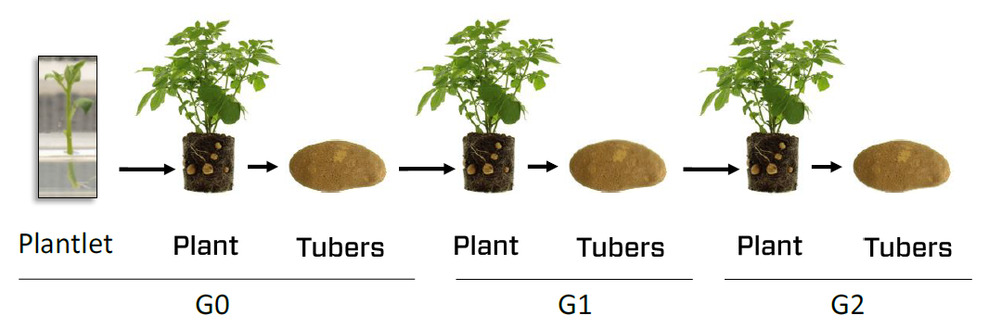

Figure 7: Generations of potato derived from vegetative propagation

Table 6: Molecular characterisation studies performed in W8
Analysis | generation analysed | Control(s) used | Reference comparators
Identifying number of integration sites (Section 3.4.1) | G0 / leaf | Russet Burbank | Russet Burbank spiked with plasmid DNA (pSIM1278 or pSIM1678)
Detection of backbone sequence (Section 3.4.2) | G0 / leaf | Russet Burbank | Ranger Russet spiked with plasmid DNA (pSIM1278)
Inheritance and genetic stability (Section 3.4.3) | G0 and G2 / leaf | Russet Burbank | —
Insert integrity and site of integration (Section 3.4.4) | G0 / leaf | Russet Burbank | —
RNAi silencing of targeted genes (Section 3.4.6)
Suppression of RNA transcripts (Section 3.4.6.1) | G2 / tuber, root, leaf, stem, flower | Russet Burbank | —
Asparagine and reducing sugar levels (Section 3.4.6.2) | G1 / tuber | Russet Burbank
Suppression of acrylamide production (Section 3.4.6.2) | G1 / tuber | Russet Burbank | —
Suppression of PPO activity  (Section 3.4.6.3) | G2 / tuber | Russet Burbank | —

Table 7: Molecular characterisation studies performed in X17
Analysis | generation analysed | Control(s) used | Reference comparators
Identifying number of integration sites (Section 3.4.1) | G0 / leaf | Ranger Russet | Ranger Russet spiked with plasmid DNA (pSIM1278 or pSIM1678) and event F10
Detection of backbone sequence (Section 3.4.2) | G0 / leaf | Ranger Russet | Ranger Russet spiked with plasmid DNA (pSIM1278)
Inheritance and genetic stability (Section 3.4.3) | G0 and G2 / leaf | Ranger Russet | —
Insert integrity and site of integration (Section 3.4.4) | G0 / leaf | Ranger Russet | F10 line
RNAi silencing of targeted genes (Section 3.4.6)
Suppression of RNA transcripts (Section 3.4.6.1) | G1 / tuber, root, leaf, stem, flower | Ranger Russet | —
Asparagine and reducing sugar levels (Section 3.4.6.2) | G1 & G2 / tuber | Ranger Russet | —
Suppression of acrylamide production (Section 3.4.6.2) | G1 & G2 / tuber | Ranger Russet | —
Suppression of PPO activity  (Section 3.4.6.3) | G2 / tuber | Ranger Russet (G4) | —

Table 8: Molecular characterisation studies performed in Y9
Analysis | generation analysed | Control(s) used | Reference comparators
Identifying number of integration sites (Section 3.4.1) | G0 / leaf | Atlantic | Atlantic spiked with plasmid DNA (pSIM1278 or pSIM1678) and line J3
Detection of backbone sequence (Section 3.4.2) | G0 / leaf | Atlantic | Atlantic spiked with pSIM1278
Inheritance and genetic stability (Section 3.4.3) | G0 and G2 / leaf | Atlantic | —
Insert integrity and site of integration (Section 3.4.4) | G? / leaf | Atlantic | J3 line
RNAi silencing of targeted genes (Section 3.4.6)
Suppression of RNA transcripts (Section 3.4.6.1) | G1 / tuber, root, leaf, stem, flower | Atlantic | —
Asparagine and reducing sugar levels (Section 3.4.6.2) | G1 / tuber | Atlantic | —
Suppression of acrylamide production (Section 3.4.6.2) | G2 / tuber | Atlantic | —
Suppression of PPO activity  (Section 3.4.6.3) | G2 / tuber | Atlantic (G3) | —

3.4 Characterisation of the inserted DNA and site(s) of insertion
A range of analyses were undertaken to characterise the genetic modification in the three lines W8, X17 and Y9. These analyses focussed on the nature and stability of the insertion and whether any unintended re-arrangements or products may have occurred as a consequence of the transformation procedure. In the analysis of the transformation results involving pSIM1278, the data are applicable to the first and second generation pairs E56 and W8, F10 and X17 and J3 and Y9. When considering the transformation results related to pSIM1678, the analysis is only applicable to W8, X17 and Y9.

3.4.1 Identifying the number of integration sites
Southern blot analysis was performed on leaf-derived genomic DNA digested with restriction enzymes and hybridised with a series of probes spanning the T-DNA region of both pSIM1278 and pSIM1678. Some of the probes matched sequences in both T-DNA regions due to the presence of the Agp and Gbss promoters in both plasmids. The results showed a single integration of the T-DNA from the pSIM1278 plasmid has occurred in the first transformation step that created E56, F10 and J3 and a single integration of the T-DNA from the pSIM1678 plasmid has occurred in the second transformation step that created W8, X17 and Y9.

3.4.2 Detection of backbone sequence
Southern blot analysis was performed on leaf-derived genomic DNA digested with restriction enzymes and hybridised with a series of probes spanning the backbone region of the plasmids. Due to commonality of sequences across the T-DNA and backbone regions, specific digests were performed to generate a unique banding pattern that when probed, would allow differentiation between the T-DNA and backbone sequences. The results from these experiments showed that there were no backbone sequences incorporated into the genome of the W8, X17 and Y9 lines. This includes the absence of the kanamycin antibiotic resistance gene that is present in both plasmids (Figure 1). As the sequences are absent in the W8, X17 and Y9 lines, they would also be absent from the progenitor lines E56, F10 and J3.

3.4.3 Inheritance and genetic stability of the inserted DNA
As commercial potatoes are vegetatively propagated, standard Mendelian segregation analysis could not be used to determine inheritance. In order to confirm that the progeny were genetically the same as the parent and to ensure the stability of the inserted DNA over time, Southern blot analysis was performed on leaf-derived genomic DNA obtained from G0 and G2 plants. A series of probes were used to examine common regions across the two T-DNA regions (e.g. Agp and Gbss promoters) and unique regions within the T-DNA inserts (e.g. Asn1 and Vlnv), which ensured that sufficient evidence of gene flow and stability was collected. The results confirmed that the inserted DNA was stably incorporated over two successive clonal generations and remained stable over this time period for lines W8, X17 and Y9. As there was no loss of DNA in the second generation lines (W8, X17 and Y9), it can be assumed that the stability and inheritance of the inserted DNA was the same for E56, F10 and J3.

3.4.4 Insert integrity and site of integration
In order to identify rearrangements, deletions and insertions in the integrated DNA, genomic DNA was mapped using probes spanning the T-DNA regions of both plasmids by Southern blotting. For this Southern blotting procedure, a range of different restriction enzymes were used to generate fragments of different sizes that would overlap in sequence, and which when probed would show the position of each labelled fragment. A representation of the digest and probe binding sites for the T-DNA region of each plasmid is shown in Figure 8.
Rearrangements, deletions and insertions detected by Southern blotting were then confirmed by a combination of PCR and DNA sequence analysis. The subsequent DNA analysis also allowed for identification of likely sites of integration in the host genome by alignment to the potato reference genome at the Michigan State University Spud DB Genome Browser.

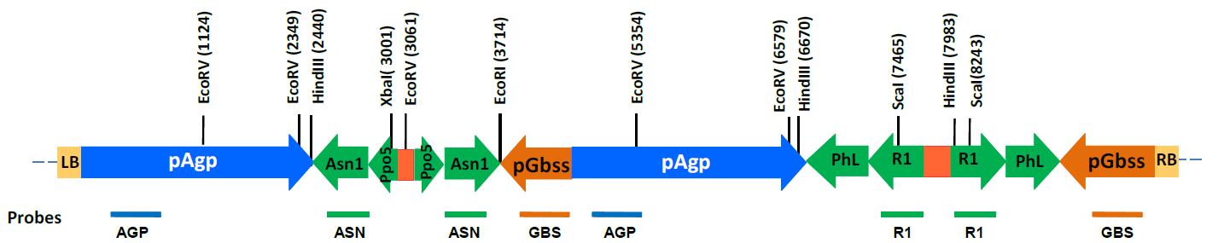
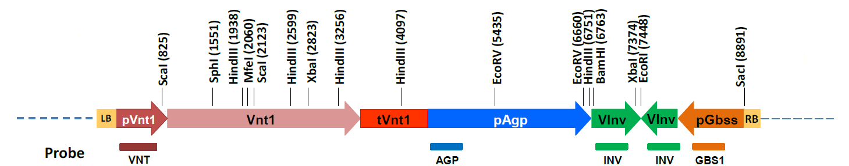
pSIM1278 T-DNA
pSIM1678 T-DNA

Figure 8: A representation of the restriction enzyme map and probe binding sites of the inserted T-DNA regions. A Southern blotting method was used to determine the structure of the inserted DNA, incorporating a range of restriction enzymes and probes specific to each plasmid insert. The two maps shown were used for the X17 event.

3.4.4.1 pSIM1278 insert structure in W8 and E56
The Applicant provided the results from Southern blotting and DNA sequence analysis for the pSIM1278 insert in Russet Burbank. Analysis of the transformed W8 event showed a full length copy of the T-DNA region, from the first Agp promoter through to the right border region from pSIM1278, has been integrated (junctions 3-4 in Figure 9), with additional rearranged elements flanking the insert.

On the left of the insert (junctions 1-3) are two tandem repeats of the Asn/Ppo cassette. In the cassette from junctions 1-2 (Figure 9), there has been a deletion of the entire left border sequence and a truncation of 35 bp from the 5′ end of the Agp promoter sequence. Although there is some sequence missing in this first promoter, the regulatory elements are intact thus this promoter should be fully functional. In the second repeated Asn/Ppo cassette (junctions 2-3), both the left and right border sequences have been deleted. The promoters and RNAi fragments are fully intact.

On the right of the insert between junctions 4-7 (Figure 9), there are three partial tandem repeats of the PhL/R1 cassette. The first repeat (junctions 4-5) is inverted and starts with a truncated right border sequence followed by the full sequence from the Gbss promoter to the PhL antisense fragment. The second repeat (junctions 5-6) is the 3′ end of the Phl/R1 cassette covering the Gbss promoter and a truncated right border. The final repeat (junctions 6-7) is a further copy of the 3′ end of the Phl/R1 cassette covering the 3′ end of the PhL sense fragment through to a truncated right border.

The location of integration for the pSIM1278 insert in W8 and E56 was identified by DNA sequence analysis and was shown to have occurred in chromosome 2. At the identified insertion site, there are no known annotated genes thus the insertion should not have disrupted any genes. The insertion of the pSIM1278 DNA resulted in a 59 bp deletion of genomic DNA.

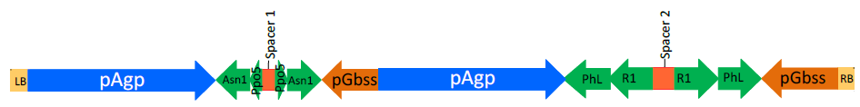
pSIM1278 insert in W8
Asn/Ppo cassette
PhL/R1 cassette
pSIM1278 T-DNA
Additional Asn/Ppo cassettes
Additional partial Phl/R1 cassettes
1
2
3
4
5
6
7

Figure 9: A map of the structure of the pSIM1278 T-DNA insert in W8 and E56

3.4.4.2 pSIM1678 insert structure in W8
The Applicant provided the results from Southern blotting and DNA sequence analysis for the pSIM1678 insert in W8. Analysis of the transformed W8 event showed a nearly full-length copy of the T-DNA region from pSIM1678 has been integrated. At the left junction, the entire left border region and 141 bp of the Rpi-vnt1 promoter has been deleted. At the right junction, 114 bp have been deleted from the right border region. Although there has been some sequence deleted from the Rpi-vnt1 promoter, the regulatory elements are intact thus this promoter should be fully functional. There are no additional rearranged elements flanking the insert.

The location of integration for the pSIM1678 insert in W8 is most likely chromosome 4. Due to a high degree of repetitive sequences in the host genome at the region surrounding the insert, the actual site of integration cannot be conclusively deduced. In this region, the insertion could have disrupted either one of two genes (purine transporter PGSC0003DMT400085139; NB-ARC domain-containing protein PGSC0003DMT400085351). Russet Burbank is a tetraploid variety that exhibits a high copy number of genes (Iovene et al. 2013) therefore it is unlikely that disruption of one allele will result in a phenotypic change. The insertion of the pSIM1678 DNA resulted in a 451 bp deletion of genomic DNA.

3.4.4.3 pSIM1278 Insert structure in F10 and X17
The Applicant provided the results from Southern blotting and DNA sequence analysis for the pSIM1278 insert in Ranger Russet. Analysis of the transformed F10 and X17 events showed a full-length copy of the T-DNA region from pSIM1278 has been integrated, with a 2 bp deletion and 6 bp filler occurring in the left border and a 55 bp deletion in the right border regions. There were no additional rearranged elements flanking the insert.

The most likely location of integration for the pSIM1278 insert in F10 and X17 is chromosome 8. The insertion of the pSIM1278 DNA has occurred within a predicted gene that encodes an uncharacterised protein (PGSC0003DMT400045203). Ranger Russet is a tetraploid variety that exhibits a high copy number of genes (Iovene et al. 2013) therefore it is unlikely that disruption of one allele will result in a phenotypic change. The insertion of the pSIM1278 DNA resulted in a 33 bp deletion of genomic DNA.

3.4.4.4 pSIM1678 insert structure in X17
The Applicant provided the results from Southern blotting and DNA sequence analysis for the pSIM1678 insert in X17. Analysis of the transformed X17 event showed a full-length copy of the T-DNA region from pSIM1278 has been integrated, with a 7 bp deletion in the left border and a 23 bp deletion in the right border regions. There are no additional rearranged elements flanking the insert.

The most likely location of integration for the pSIM1678 insert in X17 is chromosome 5. Due to the presence of repetitive sequences in this chromosome, the actual insertion site could only be predicted to within a 2000 bp region. Within this region, it is likely the insertion of the pSIM1678 DNA has occurred within a predicted gene that encodes an uncharacterised protein (PGSC0003DMT400060077). As Ranger Russet is a tetraploid variety that exhibits a high copy number of genes (Iovene et al. 2013), it is unlikely that disruption of one allele will result in a phenotypic change The insertion of the pSIM1278 DNA resulted in a 33 bp deletion of genomic DNA.

3.4.4.5 pSIM1278 insert structure in J3 and Y9
The Applicant provided the results from Southern blotting and DNA sequence analysis for the pSIM1278 insert in Atlantic. The Applicant reported some difficulty in obtaining the full sequence for a small region where there has been an inversion and duplication of the Agp promoter in the Asn/Ppo cassette (junction 2 in Figure 10). Analysis of the transformed J3 and Y9 events showed an almost full-length copy of the T-DNA region from pSIM1278 has been integrated (from junctions 2-3 in Figure 10). This insert contains a 58 bp truncation of the first Agp promoter, however as no regulatory sequences were missing, this promoter should be fully functional. Flanking the main insert are additional elements as described below.

On the 5’ end of the insert (from junctions 1-2 in Figure 10), there is an inverted duplication of the first Asn/Ppo cassette plus a portion of the Agp promoter from the second cassette. There has been some deletion of DNA at junction 2 between the two Agp promoters but both promoters contain all the regulatory sequences and should be active. The Agp promoter at junction 1 (Figure 10), which is orientated towards the flanking region of the genome, does not contain any regulatory sequences and would not be functional.

At the 3’ end of the insert (from junctions 3-4 in Figure 10) there is a partial inversion of the PhL/R1 cassette up to the spacer 2 sequence. The Gbss promoter that is orientated towards the hosts genomic DNA is intact and would be functional. An assessment was made for this promoter to drive expression of a novel transcript and the results are presented in Section 3.4.5. If the additional Gbss promoter drives transcription of the partial PhL/R1 inverted repeat, this most likely would be silenced by the full PhL/R1 RNAi insert that specifically targets the PhL/R1 sequences.

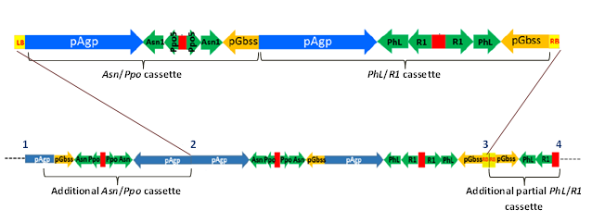
pSIM1278 insert in J3/Y9
pSIM1278 T-DNA

Figure 10: A map of the structure of the pSIM1278 T-DNA insert in J3 and Y9

The most likely location of integration for the pSIM1278 insert in J3 and Y9 is chromosome 6. At the predicted insertion site, there is an uncharacterised gene (function unknown) within 1 kb of the insert but the insertion does not disrupt this gene. Transfer of the T-DNA from pSIM1278 into the chromosome resulted in a 21 bp deletion of host genomic DNA and a 5 bp addition to the left border junction of the insert, typical for T-DNA inserts.

3.4.4.6 pSIM1678 insert structure in Y9
The Applicant provided the results from Southern blotting and DNA sequence analysis for the pSIM1678 insert in Y9. Analysis of the transformed Y9 event showed an almost full-length copy of the T-DNA region from pSIM1678 has been inserted (from junctions 1-2 in Figure 11), with an additional element on the right-hand side of the T-DNA insert.
Rpi-vnt1 cassette
Vlnv cassette
Additional Vnlv cassette
pSIM1678 insert in Y9
pSIM1678 T-DNA
1
2
3

Figure 11: A map of the structure of the pSIM1678 T-DNA insert in Y9

At junction 1 (Figure 11), the LB region and 36 bp of the Rpi-vnt1 promoter has been deleted. Although the promoter has been slightly truncated, no regulatory sequences have been removed thus the promoter should still be functional.

At the right side of the insert, there was a partial inverted duplication of the Vlnv cassette. Analysis of the right-border junction (position 2 in Figure 11) showed that there has been some truncation of both right-border regions. This sequence is followed by a fully intact Gbss promoter, orientated towards the flanking region of genomic DNA, and a partial copy of the Vlnv antisense fragment (133 bp of the full 498 bp fragment) that forms a junction with the genomic DNA (junction 3 in Figure 10).
An assessment was made for the duplicated Gbss promoter to drive expression of a novel transcript and the results are presented in Section 3.4.5. Should the Gbss promoter drive expression of an RNA transcript at this site, it would contain the Vlnv sequences which most likely would be targeted for destruction by the upstream Vlnv RNAi insert.

The most likely location of the integration site for pSIM1678 insert in Y9 is chromosome 5. At the predicted insertion site, there are no annotated genes in this location thus the insertion should not disrupt any genes. Transfer of the T-DNA from pSIM1678 into the chromosome resulted in a 278 bp deletion of host genomic DNA and a 7 bp addition to the right border junction of the insert, typical for T-DNA inserts.

3.4.5 Open read frame (ORF) analysis
The Applicant used proprietary Python script to identity all start-to-stop ORFs in both the inserted DNA and junctions between the insert and genomic DNA. All six reading frames were analysed. ORFs of 30 or more amino acids were captured for further analysis, as proteins shorter than 29 amino acids would not meet the minimum requirements of a 35% match over an 80 amino acid sequence (Codex 2009). The number of ORFs identified in each of the lines are presented in Table 9.

Table 9: Number of ORFs identified in W8, X17 and Y9
Number of ORFs identified |  | W8 | X17 | Y9
pSIM1278 | Within the insert | 29 | 30 | 30
 | Left junction | 0 | 0 | 0
 | Right Junction | 0 | 1 | 1
pSIM1678 | Within the insert | 42 | 43 | 45
 | Left junction | 2 | 0 | 1
 | Right Junction | 0 | 1 | 0

Although the number of potential ORFs for each transformation event seems high (range from 73-77 ORFs per transformation), the majority of the ORFs are not associated with a promoter thus would not be transcribed. The VNT1 protein was correctly identified as an ORF, is associated with a promoter and thus would be transcribed. As this is a novel protein, the potential allergenicity and toxicity are reviewed in Section 4.

As the ORF analysis includes the pSIM1278 transformation event, the analysis would also be relevant for the E56, F10 and J3 lines.

3.4.5.1 Bioinformatic analysis for potential allergenicity
The Applicant has provided the results of in silico analyses comparing the amino acid sequences identified as ORFs (Table 9) to known allergenic proteins in the Food Allergy Research and Resource Program (FARRP) dataset, which is available through AllergenOnline (University of Nebraska). The version of the database used (v16) contains 1,956 entries. Three types of analyses were performed for this comparison:

(a) Full length sequence search – a FASTA alignment was performed comparing the whole sequence to the database entries. Significant homology was determined when there was (i) greater than 50% homology between query protein and database entry and (ii) the E-value was less than 10⁻⁴. The lower the E-value, the less likely the similarity is due to chance.

(b) 80-mer sliding window search – a FASTA alignment was performed comparing all contiguous 80 amino acids within the ORF to the database entries. Matches were identified if there was greater than 35% homology (E value < 10⁻⁴).

(c) 8-mer exact match search – A FASTA alignment was performed comparing contiguous 8 amino acids within the ORF to the database entries. Matches were identified if there was 100% homology.

In all three lines (W8, X17 and Y9), a protein generated by an ORF coinciding with the inverted Vlnv gene fragments in the pSIM1678 insert matched a minor allergenic vacuolar invertase protein from tomato (S. lycopersicum; AAL75449, AAL75450). The vacuolar invertase proteins from the tomato and potato share 95% sequence homology but have different glycosylation patterns that can impact allergenicity potential. In the potato, the native protein has not been identified as allergenic. In addition, even if the resulting ORF generated from the pSIM1678 were to be transcribed it would be processed by the RNAi pathway for silencing the native Vlnv mRNA thereby reducing any allergenicity concerns.

3.4.5.2 Bioinformatic analysis for potential toxicity
The Applicant provided results from in silico analyses comparing the amino acid sequences identified as ORFs to known protein toxins identified in the NCBI Protein databases. A BLASTP search (v2.6.1) comparing the potential peptides generated by the identified ORFs to proteins designated as toxins, did not identify homology to any biologically relevant toxins in W8, X17 or Y9. There was homology to enzymes found in toxigenic bacteria but the enzymes themselves are not considered toxins.

3.4.6 RNAi silencing of targeted genes
To determine if the RNAi cassettes developed by the Applicant were able to silence the target genes, the Applicant has provided data looking at mRNA and protein levels or protein activity in the secondary transformed lines (W8, X17 and Y9) compared to their parental untransformed lines (Russet Burbank, Ranger Russet and Atlantic respectively).

3.4.6.1 Suppression of RNA transcripts
Northern blotting was used to examine the levels of each of the target gene transcripts (mRNA) in the transformants. Expression levels were examined in the edible portion of the plant, the tuber, but also in the flower, leaf, stem and root tissue.

Analysis of transcript levels of the targeted genes showed that in the tuber, there were decreased levels of asparagine synthetase, polyphenol oxidase and vacuolar invertase in W8, X17 and Y9. Phosphorylase L was also suppressed in the W8 and Y9 tubers. There was no decrease observed in the water dikinase mRNA in any of the events. The lack of water dikinase suppression was also observed for the E12 line from Application A1128 (FSANZ 2016).

Suppression of asparagine synthetase also occurred in the flowers in all lines and in the leaves of X17 and Y9. Vacuolar invertase was also suppressed in the flowers of X17 and Y9. There was no suppression of the target transcripts in stem and root tissue.

No data were specifically provided for the E56, F10 or J3 lines however, the RNAi targeting of the genes asparagine synthetase and polyphenol oxidase was introduced in the first transformation step, therefore it can be assumed that these genes are being similarly suppressed in the progenitor lines. This is further supported by the results presented in Application 1128 (FSANZ 2016) for the E12 line, where only asparagine synthetase and polyphenol oxidase genes were suppressed in the tuber.

3.4.6.2 Gene silencing effects on asparagine and reducing sugar levels
The Applicant has shown that the RNAi has suppressed the expression of the gene transcripts targeting the enzymes involved in regulating asparagine levels and carbohydrate hydrolysis. As production of acrylamide is dependent on the availability of free asparagine and reducing sugars in the tuber, further analysis was performed to determine if the gene suppression corresponded to a reduction in the levels of asparagine and reducing sugars.

Asparagine levels were determined by HPLC and results showing the change in asparagine levels between the parental controls and transformed lines are presented in Table 10. Both total and free levels are presented. Total levels look at all the asparagine and aspartic acid that are bound up in proteins and include free or unbound forms. The free levels only include unbound asparagine that arises from the biosynthesis of new amino acids and the hydrolysis of proteins. The results shows that there was a reduction in total asparagine levels of 1.6-1.8 fold and a reduction of free asparagine of 3.4-4.6 fold in the W8, X17 and Y9 lines. These results were statistically significant. This indicates that for the W8, X17 and Y9 lines there is a correlation between reduced expression of the asparagine synthetase gene and reduced asparagine levels. As asparagine synthetase was targeted in the first transformation step, it can be assumed that the change in asparagine also occurs in the progenitor lines E56, F10 and J3. Some data were provided for F10 and J3 that confirms a reduction in asparagine levels and this was also reported in the E12 line from Application 1128 (FSANZ 2016).

Table 10: The change in asparagine levels in the transformed lines compared to the parental controls
Variable | Fold Change
 | W8 | X17 | Y9
Total Asparagine | 1.8¹ | 1.8 | 1.6
Free Asparagine | 3.4 | 4.4 | 4.6
1. Bolded and underlined results indicate statistical significance when comparing the control to the transformed event.

The results presented by the Applicant for reducing sugars were obtained by chromatography. Reducing sugars are simple sugars like glucose and fructose that contain an aldehyde group, which can act as a reducing agent in a redox reaction. Reducing sugar levels are increased by the hydrolysis of starch and sucrose, two major carbohydrate forms found in plants. The enzymes targeted by RNAi, phosphorylase L and vacuolar invertase, hydrolyse starch and sucrose respectively. The levels of sucrose were also included in the results.

As shown in Table 11, for fresh tubers, there was a 1.1-1.6-fold higher concentration of sucrose associated with a 2.7-4.0-fold decrease in reducing sugars present in W8, X17 and Y9. These changes were statistically significant.

Table 11: The change in sucrose and reducing sugar levels between transformed lines and parental controls in freshly harvested or 6-month cold-stored potatoes
Storage | Sucrose (fold change) |  |  | Reducing Sugars  (fold change)
 | W8 | X17 | Y9 | W8 | X17 | Y9
Fresh | 1.6¹ | 1.3 | 1.1 | 3.8 | 4.0 | 2.7
8-10°C | 2.1 | 1.7 | 1.3 | 2.3 | 3.0 | 6.9
3°C | 5.3 | 2.5 | 0.8 | 7.0 | 0.8 | 3.0
1. Bolded and underlined results indicate statistical significance when comparing the control to the transformed event.

Although the Applicant did not present gene transcript data from the progenitor lines, analysis of lines X17 (this Application) and E12 (FSANZ 2016) indicates that the carbohydrate enzyme PhL targeted by the first transformation step is not being effectively silenced. This is further supported by results showing no change in sucrose and reducing sugar levels between F10 and J3 to their parental controls. This was also observed in the E12 line (FSANZ 2016). Furthermore, these data indicate that for the W8, X17 and Y9 lines, the changes in sucrose and reducing sugar levels can only be attributed to a suppression of the vacuolar invertase gene.

As vacuolar invertase also plays a role in the process of cold-induced sweetening (CIS) (Sowokinos 2001), levels of sugars were assessed in fresh potatoes and potatoes stored at 3°C and 8°C (W8 and X17) or 3°C and 10°C (Y9) for 6 months and compared to the amounts in the parental controls. The data presented (Table 11) showed that in the transformed lines, sucrose was consistently higher and generally increased over the storage time. These changes were statistically significant for the W8 and X17 lines but not for the Y9 potatoes. The sucrose data correlated well with a consistent and statistically significant decrease in accumulation of reducing sugars in the transformed lines W8, X17 and Y9 after 6 months of cold storage. These data indicate that the breakdown of sucrose at lower temperatures has been impaired in the W8 and X17 lines and to a lesser extent in the Y9 line and this can be correlated with the suppression of the vacuolar invertase gene. As vacuolar invertase was not targeted for suppression in the progenitor lines, no data on cold-induced sweetening was presented for E56, F10 or J3.

3.4.6.3 Gene silencing effects on acrylamide production
In order to determine the effectiveness of the RNAi suppression of genes associated with asparagine and reducing sugar levels on the acrylamide potential of the transformed potato lines, chips were prepared from fresh and cold-stored potatoes kept at 3°C and 8°C (W8 and X17) or 3°C and 10°C (Y9) for 6 months. Acrylamide levels were measured using the procedure specified by the FDA (2003).

The data presented in Table 12 shows that acrylamide production in fries made from transformed lines was significantly reduced compared to parental controls, especially after the tubers had been kept in cold storage. Combining this reduction in asparagine levels with the suppression of the PhL and VInv genes in the W8 and X17 lines and the VInv gene in the Y9 line, which resulted in lower levels of reducing sugars, there was a greater than 80% reduction in acrylamide formed in the cooked fries. These data demonstrate that decreasing the amount of asparagine and reducing sugars in potato tubers did result in a reduction in acrylamide potential.

Table 12: Percent change of acrylamide levels between transformed lines and parental controls in fries prepared from freshly harvested or 6 month cold-stored potatoes
Storage | Percent (%) Reduction
 | W8 | X17 | Y9
Fresh | 85 | 86 | 85
8-10°C | 84 | 84 | 89
3°C | 86 | 93 | 97
1. Bolded and underlined results indicate statistical significance when comparing the control to the transformed event.

Data were also presented for the F10 and J3 lines, which showed a 60-67% reduction in acrylamide production. In combination with data reported for line E12 (FSANZ 2016), this indicates that a reduction in asparagine levels alone can lead to a significant reduction in the amount of acrylamide being produced upon cooking.

3.4.6.4 Suppression of PPO activity
In order to correlate the results examining expression levels of the Ppo5 transcript in the tuber with PPO activity, a qualitative colorimetric assay was performed that examined enzyme action on the substrate catechol. Results were compared between the untransformed parental lines and lines W8, X17 and Y9. For all three lines, PPO activity was significantly reduced compared to that in the untransformed parental controls. This result was not unremarkable given that the northern blot analysis (see Section 3.4.6.1) showed suppression of the Ppo5 transcript. As the gene fragments targeting Ppo5 were introduced in the first transformation step, it can be assumed that PPO activity would also be similarly reduced in the E56, F10 and J3 lines.

3.4.7 Conclusion
In all the potato lines examined, the data provided by the Applicant showed that a single integration event has occurred with each transformation step and the most likely location of the insertions have been identified. In some instances, endogenous genes have been disrupted but, as the parent potatoes are tetraploid varieties with multiple gene copies, an alternate gene copy would most likely be activated resulting in minimal impact on the plant. In every potato line, a fully intact insert containing the expression cassettes has been integrated and, except for X17, additional rearranged elements have been identified flanking the main insert. Molecular studies have also confirmed that only the required sequences (T-DNA) have been integrated into the modified potatoes, with no antibiotic resistance genes or other plasmid backbone sequences being present. The introduced genetic elements are stably maintained through clonally propagated generations.

Analysis of mRNA associated with the genes targeted by RNAi demonstrated that Asn1, Ppo5 and Vlnv have been suppressed in W8, X17 and Y9. PhL was suppressed only in the W8 and Y9 tubers while there was no reduction in expression of R1 in any of the lines. The suppression of these genes has resulted in potatoes with reduced black spot bruising and reduced acrylamide potential.

4 Characterisation and safety assessment of novel substances
Two novel substances are expressed in the lines W8, X17 and Y9, the novel protein VNT1 and dsRNA molecules targeting Asn, PhL, R1, VInv and Ppo5 for RNAi suppression. In the E56, F10 and J3 lines, only dsRNA molecules targeting the Asn, PhL, R1 and Ppo5 genes are present. The Applicant provided data from a range of analyses undertaken to characterise the novel protein being produced in W8, X17 and Y9 and provided discussion of the safety of dsRNA in W8, X17, Y9, E56, F10 and J3. In the consideration of the safety of newly expressed substances it is important to note that a large and diverse range of proteins and small dsRNAs are ingested as part of the normal human diet without any adverse effects.

4.1 Newly expressed protein
Only a small number of dietary proteins have the potential to impair health, because they have anti-nutrient properties or they can cause allergies in some consumers (Delaney et al. 2008). As proteins perform a wide variety of functions, different possible effects have to be considered during the safety assessment including potential toxic, anti-nutrient or allergenic effects.

To effectively identify any potential hazards, knowledge of the characteristics, concentration and localisation of all newly expressed proteins in the organism as well as a detailed understanding of their biochemical function and phenotypic effects is required. It is also important to determine if the newly expressed protein is expressed in the plant as expected, including whether any post-translational modifications have occurred.

The Applicant has submitted the following unpublished studies regarding the molecular characterisation of the novel protein introduced into lines W8, X17 and Y9.

Unpublished studies
- Expression of Rpi-vnt1 in W8 Tuber and Leaf Tissues (2016) Report 15-70-SPS-MOL-02, SPS Regulatory Lab, Simplot Plant Sciences.
- Expression of Rpi-vnt1 in X17 tuber and leaf tissues (2016) Report 15-09-SPS-MOL, SPS Regulatory Lab, Simplot Plant Sciences.
- Expression of Rpi-vnt1 in Y9 tuber and leaf tissues (2016) Report 15-17-SPS-MOL, SPS Regulatory Lab, Simplot Plant Sciences.
- 2013 Field Efficacy of Potato Events W8, X17 and Y9 against Phytophthora infestans (Late Blight) (2015) Report 13-04-SPS-ENV, Simplot Plant Sciences.
- 2014 Field Efficacy of Potato Events W8, X17 and Y9 against Phytophthora infestans (Late Blight) (2015) Report 14-04-SPS-ENV, Simplot Plant Sciences.
- 2014 Field Efficacy of Potato Events W8, X17 and Y9 against Phytophthora infestans (Late Blight) Strain US-24 (2016) Report 16-72-SPS-ENV, Simplot Plant Sciences.

4.1.1 Description of the VNT1 protein
Plasmid pSIM1678, which was used to generate W8, X17 and Y9, contains a gene cassette with the native Rpi-vnt1 gene, promoter and terminator from S. venturii, a wild relative to the S. tuberosum. This gene encodes an 891 amino acid protein called VNT1 and is one of three variants expressed in S. venturii (Foster et al. 2009). The predicted size of the mature protein is 101.97 kDa.

VNT1 belongs to a group of common plant resistance proteins (R-proteins), that contain nucleotide binding (NB) and leucine-rich repeat (LRR) domains. These NB-LRR proteins are used by the plant to detect the presence of pathogenic molecules known as effectors that are indicative of an infection (Jones and Dangl 2006; McHale et al. 2006). Once the NB-LRR has detected the presence of an effector, there is activation of the plants defence responses and eventual development of immunity to the pathogen. The pathogen that VNT1 recognises and mediates a response to is the oomycete Phytophthora infestans (Foster et al. 2009; Jones et al. 2014). This pathogen causes foliar late blight, a devastating disease responsible for the Great Irish Potato Famine and which still poses a major threat to global potato cultivation.

Although VNT1 is unique to the S. venturii species, it shares high homology at both the amino acid and nucleotide level to several R-proteins, actual and predicted, from edible food crops across the Solanaceae family, including potatoes, tomatoes and capsicums (sweet and chilli peppers).

4.1.2 Expression of the Rpi-vnt1 gene and VNT1 protein in potato tissues
In order to identify the tissues in which VNT1 was actively transcribed, real-time PCR was used to investigate the presence of Rpi-vnt1 mRNA in leaves and tubers from W8, X17 and Y9 and their parental controls (Russet Burbank, Ranger Russet and Atlantic). The expression levels of the Rpi-vnt1 transcripts were compared to that of leaf tissue from S. venturii. Transcripts of Rpi-vnt1 were not detected in the leaf or tuber tissue of the parental controls, which is expected as these varieties do not have the gene. Rpi-vnt1 was expressed in the transformed lines, with high expression in the leaf and only minimal levels in the tuber. These data confirmed that the gene for VNT1 was being transcribed in the transformed lines and is only minimally expressed in the tuber.

Western blotting was used to examine protein expression in leaves and tuber tissue from each line (W8, X17 and Y9) and the respective parental controls (Russet Burbank, Ranger Russet and Atlantic). The results did not conclusively show that the VNT1 protein was expressed in the transformed lines. The Applicant noted two main reasons for this:

- the expressed protein appeared to undergo degradation because the most consistent band detected was at 75 kDa rather than at the expected 102 kDa
- there were potential issues with cross-reactivity of the antibody with other possible native R-proteins.

The fact that VNT1 was not clearly detected in the transformed lines was not unexpected as R-proteins are known to be expressed at low levels and are considered to be intractable proteins (Bushey et al. 2014; McHale et al. 2006). The cross-reactivity of the antibody could be related to the target to which it was designed. The antibody used was raised against a section of the VNT1 LRR domain. The LRR domain is thought to contain the effector or pathogen-mediated recognition sites and thus should contain unique sites for each R-protein. However, the actual recognition sites are not yet known, especially for VNT1, thus the peptide to which the antibody was made may not have been specific enough. Using a recombinant form of the protein expressed in Nicotiana benthamiana, the antibody was shown to have a limit of detection of ~20 pg, indicating the amount expressed in the transformed potato lines was likely below this amount.

4.1.3 Characterisation of VNT1 proteins in potato or equivalence of bacterially-produced forms
Although the level of protein expression was below detection, late blight field efficacy studies were performed on W8, X17 and Y9 and their respective parental controls. These studies were performed at a total of four sites (PA, ID, ND and MI) during the 2013 and 2014 growing seasons. Using a randomised complete block design, replicate plots (n=4) were established containing rows of five plants of each of the controls (Russet Burbank, Ranger Russet and Atlantic) and each of the test lines (W8, X17 and Y9), with late blight-susceptible spreader plants (Red Lasoda or Atlantic) planted on either side of the control and test samples. Region specific agronomic practices were used for pest control and fertiliser application. If fungicide was required, a treatment that would not affect P. infestans was used. The plots were irrigated regularly to ensure an environment that would facilitate infection and the spreader plants only were inoculated with P. infestans. Four common pathogenic strains were investigated (US-8, US-22, US-23 and US-24). These four strains were the dominant strains isolated from epidemics that occurred in North America (including Canada) between the years 2009-2011 (Danies et al. 2013) and are still persistent to the present day.

All three transformed lines W8, X17 and Y9 were fully resistant to P. infestans strains US-8, US-22 and US-23 and partially resistant to the US-24 strain, whereas the parental controls showed full susceptibility, over the time period analysed. The data imply the VNT1 protein is being expressed in the transformed lines and is providing late-blight protection.

Due to the intractability of the protein in leaf tissue, no analysis of unexpected post-translational modifications was able to be performed on the VNT1 protein expressed in the transformed potatoes. The Applicant did provide evidence that the gene was transcribed and that the transformed lines were significantly resistant to foliar late blight infection compared to their parental controls. This evidence suggests that the protein is being expressed and is similar to the native protein due to the similarity of function. The protein is also being expressed in a closely related species to the S. venturii, reducing the possibility of unexpected modifications occurring because there would be a high degree of similarity in the cellular machinery that is involved in protein modifications between the S. venturii and S. tuberosum. The Applicant did attempt expression in an alternative plant system (N. benthamiana) but again the protein was expressed at low levels and sufficient amounts could not be purified for further analysis.

4.1.4 Bioinformatics analyses of VNT1

4.1.4.1 Assessment of VNT1 allergenicity
The Applicant provided the results of in silico analyses comparing the VNT1 amino acid sequence to known allergenic proteins in the FARRP dataset, using the same dataset and search criteria as outlined in Section 3.4.5.1. The FASTA search did not identify any known allergens with homology to VNT1.

4.1.4.2 Assessment of VNT1 toxicity
The Applicant has provided the results of in silico analyses comparing the amino acid sequence of VNT1 to proteins identified as “toxins” from the NCBI protein databases. A BLASTP search identified five potential toxins with a sequence overlap of greater than 50% but similarity of less than 30%.
All of the toxigenic proteins identified were plant resistance-like proteins that provide protection from pathogenic microorganisms. As resistance proteins exist in the majority of plants including food crops (McHale et al. 2006) and to date, have not been shown to have adverse effects after consumption of food or feed, it can be concluded that VNT1 is not homologous to any biologically relevant toxins.

4.1.4.3 Assessment of pepsin digestibility
To confirm the digestibility of VNT1, potential cleavage sites were investigated by FSANZ using the amino acid sequence of VNT1 and the PeptideCutter tool in the ExPASy Proteomics Site. VNT1 has multiple cleavage sites for pepsin (214 sites at pH 1.3 and 251 sites at pH >2), trypsin (111 sites), chymotrypsin (69 high-specificity sites, 217 low-specificity sites) and endopeptidases (166 sites). On this basis, VNT1 is considered likely to be as susceptible to digestion as the vast majority of dietary proteins.

4.1.5 Conclusion
The bioinformatic analysis confirmed the expressed protein is unlikely to be allergenic or toxic and would be as susceptible to digestion as the vast majority of dietary proteins. Although protein characterisation studies were unable to be performed due to the intractability of the protein, expression of a gene transcript was confirmed for all lines, with high levels in the foliage and minimal levels in the tuber. Even though the protein expression levels were very low, this was sufficient to provide resistance to three common P. infestans strains in W8, X17 and Y9.

4.2 Newly expressed dsRNA

4.2.1 Description of the dsRNA
There were two gene cassettes introduced into all the lines (E56, F10, J3, W8, X17 and Y9) containing DNA sequences that target the four genes Asn1, Ppo5, PhL and R1, and a third gene cassette containing DNA sequences from the Vlnv gene introduced into the W8, X17 and Y9 lines. These sequences include both sense and antisense fragments of DNA from either the coding or promoter regions of the target genes. When these sequences are transcribed, the complementary base pairs of the sense and antisense strands will bind forming a dsRNA molecule, with a hairpin loop. These molecules are then processed by the RNAi post-transcriptional regulatory pathway in the cell, forming a RNA-induced silencing complex. This complex binds to the target gene mRNA resulting in cleavage and degradation of the mRNA. This process exists in most eukaryotic organisms, including food-based crops.

Evidence has been provided by the Applicant to show that the target genes Asn1, Ppo5, PhL and Vlnv have been suppressed in the tubers (Section 3.4.6), indicating that the associated dsRNA molecules are being expressed. As there was no suppression of the R1 gene, no comment can be made about the expression of the dsRNA that targets this gene.

4.2.2 Potential of novel protein being produced
It is highly unlikely that the dsRNA molecules formed from the transcription of the DNA sequences introduced into the potatoes would be translated into a protein that might cause an adverse effect. Firstly, the hairpin secondary structure that is formed after these fragments are transcribed would prevent engagement of the 40S ribosomal subunit necessary to initiate translation at the 5’ end of the RNA (Kozak 1989).
The structure of the hairpin would also prevent unwinding of the duplex such that the 40S subunit would be unable to advance along the sequence. Additionally, dsRNA is cleaved into smaller microRNA that would have limited potential for translation. Therefore, it is expected that no novel proteins would be produced as a consequence of these genetic modifications.

4.2.3 History of Safe Use
In a recent review by FSANZ (2013), it was concluded the weight of evidence in the published literature on gene silencing does not support the view that dsRNA and RNAi mediators, ingested as part of the normal human diet, have any impact on human gene expression or are likely to have adverse consequences for humans. Nucleic acids, including dsRNA, are already abundantly present in the human diet from both plant and animal sources (Ivashuta et al. 2009; Carthew and Sontheimer 2009). Upon ingestion, enzymes and pH changes in saliva, stomach and intestines degrade nucleic acids into simple components (Hickerson et al. 2008; Martinez et al. 2015; Title et al. 2015), which can then be absorbed or excreted. Even if intact or partially degraded nucleic acid molecules arrive in the intestinal region, the large size, hydrophobicity and charged nature of the molecules will limit absorption across the cell barrier lining the intestinal tract. This has been highlighted by the ineffectiveness of gene therapy strategies using naked DNA. Furthermore, there is no scientific basis for suggesting that, when present as a result of the genetic modification of a plant, dsRNA and RNAi mediators possess different properties or pose a greater risk than those already naturally abundant in foods from conventional plants, animals and microorganisms such as yeasts.

4.2.4 Conclusion
There are no concerns regarding the safety of the dsRNA in W8, X17, Y9, E56, F10 and J3. The available data do not indicate that the dsRNA possesses different characteristics, or is likely to pose a greater risk, than other RNAi mediators naturally present in potato. A history of safe human consumption of RNAi mediators exists, including those with homology to human genes. The evidence published to date also does not indicate that dietary uptake of such RNA from plant food is a widespread phenomenon in vertebrates (including humans) or, if it occurs, that sufficient quantities are taken up to exert a biologically relevant effect.

5 Compositional analysis
The main purpose of compositional analyses is to determine if, as a result of the genetic modification, an unexpected change has occurred to the food. These changes could take the form of alterations in the composition of the plant and its tissues and thus its nutritional adequacy. Compositional analyses can also be important for evaluating the intended effect where there has been a deliberate change to the composition of the food.

The classic approach to the compositional analyses of GM food is a targeted one. Rather than analysing every possible constituent, which would be impractical, the aim is to analyse only those constituents most relevant to the safety of the food or that may have an impact on the whole diet. Important analytes therefore include the key nutrients, toxicants and anti-nutrients for the food in question. The key nutrients and anti-nutrients are those components in a particular food that may have a substantial impact in the overall diet. They may be major constituents (fats, proteins, carbohydrates or enzyme inhibitors such as anti-nutrients) or minor constituents (minerals, vitamins). Key toxicants are those toxicologically significant compounds known to be inherently present in an organism, such as compounds whose toxic potency and level may be significant to health (e.g. glycoalkaloids in potatoes).

There are a number of key components in potato that are considered important for compositional analysis (OECD 2015; OECD 2002). As a minimum, the key nutrients of potato tubers appropriate for a comparative study include the proximates (dry matter, moisture, carbohydrates, protein, fat), the most highly prevalent vitamins and minerals (vitamin B3, vitamin C and inorganic molecules such as potassium) and the anti-nutrient glycoalkaloids. In the analysis of carbohydrates, both crude fibre and sugar levels are measured. Furthermore, as the RNAi suppression targets enzymes that would impact the levels of reducing sugars and asparagine, a comparative study should include total and free amino acids and reducing sugar levels.

5.1 Study design and conduct for key components
Field trials were conducted for lines F10, J3, W8, X17 and Y9 at several potato-growing regions in the United States during the 2009 to 2014 growing seasons. As E56 is not intended for commercialisation, no field trials were performed for this line.

The agronomic practices and pest control measures used were location-specific and were typical for all aspects of potato cultivation including soil preparation, fertiliser application, irrigation and pesticide-based control methods. The materials tested in the field trials included the transformed potato, the parental control and a range of reference varieties. The material planted was either mini-tubers (G0) or field-grown tubers (FG). The field trials were established in a randomised complete block design, with replicates of 2, 4 or 6 rows of 20 foot long plots. Although some trials occurred in the same county over two years, the trials were not planted in the same location. Specific information for the field trials is presented in Table 13.

The compositional analyses were based on internationally recognised procedures including official methods specified by the Association of Official Analytical Chemists (AOAC), the USDA and published articles or technical notes from industrial-based sources. The analyses were performed at either the Simplot Plant Sciences facility or through contracted services from Covance Laboratories.

Table 13: Field trial information for the F10, J3, W8, X17 and Y9 lines
Line | Growth Seasons | Number of sites | Number of replicates | Reference Varieties
F10 | 2009-2011 | 11 | 3 | Atlantic, Chieftain, IdaRose, Ranger Russet, Red Norland, Russet Burbank, Snowden and Proprietary varieties
J3 | 2010-2011 | 15 | 3-5 | Atlantic, Chieftain, IdaRose, Ranger Russet, Red Norland, Russet Burbank, Snowden and Proprietary varieties
W8 | 2012-2013 | 11 | 3-4 | Bintje, Golden Sunburst, Nicolet, Ranger Russet, Red Thumb, Russet Burbank, TX 278
X17 | 2013-2014 | 8 | 4 | Atlantic, Bintje, Golden Sunburst, Lamoka, Nicolet, Red Thumb, Russet Burbank, Russet Norkotah, TX278
Y9 | 2014 | 7 | 4 | Bintje, Golden Sunburst, Lamoka, Nicolet, Russet Burbank, Russet Norkotah, TX278

Unpublished studies
- Compositional assessment of F10 compared to Ranger Russet (2016) Report 15-61-SPS-COMP, Covance Laboratories Inc, Madison, WI & Simplot Plant Sciences, Boise, ID.
- Compositional assessment of J3 compared to Atlantic (2016) Report 15-62-SPS-COMP, Covance Laboratories Inc, Madison, WI & Simplot Plant Sciences, Boise, ID.
- Compositional assessment of W8 compared to Russet Burbank (2016) Report 15-47-SPS-COMP (13-36-SPS-BIO, 12-13-SPS-BIO & 12-19-SPS-BIO), Covance Laboratories Inc, Madison, WI & Covance Laboratories Inc, Greenfield, IN.
- Compositional assessment of X17 compared to Ranger Russet (2016) Report 15-51-SPS-COMP (14-11-SPS-BIO & 13-36-SPS-BIO), Covance Laboratories Inc, Madison, WI & Covance Laboratories Inc, Greenfield, IN.
- Compositional assessment of Y9 compared to Atlantic (2016) Report 15-112-SPS-COMP (14-11-SPS-BIO & 13-36-SPS-BIO), Covance Laboratories Inc, Madison, WI & Covance Laboratories Inc, Greenfield, IN.

5.2 Analyses of key components in tubers
Homogenised samples were prepared for analysis using 4-6 whole raw tubers, including the peel. The analytes that were measured in these samples are listed in Table 14. In total, 38 different analytes were measured. Statistical analyses were performed using SAS 9.3 (SAS Institute, Cary, NC). For each analyte, ‘descriptive statistics’ (mean and standard error) were generated. A linear mixed model analysis of variance (ANOVA) was used by combining data from multiple test years and locations. In assessing the significance of any difference between the mean analyte value for lines F10, J3, W8, X17 and Y9 and their appropriate parental controls, a P-value of 0.05 was used. This means that approximately 5% of statistically significant differences are expected to occur due to chance alone.

Table 14: Analytes measured in the potato samples
Proximates and Fibre (7)
Protein |  | Fat |  | Ash (dry matter)
Crude Fibre |  | Carbohydrates |  | Calories
Moisture
Vitamins (3)
Vitamin B3 |  | Vitamin B6 |  | Vitamin C
Minerals (3)
Copper |  | Magnesium |  | Potassium
Total Amino Acids (18)
Alanine  Arginine  Aspartic acid + Asparagine  Cystine (including Cysteine)  Glutamic Acid + Glutamine Glycine |  | Histidine  Isoleucine  Leucine  Lysine  Methionine  Phenylalanine |  | Proline  Serine  Threonine  Tryptophan  Tyrosine  Valine
Free Amino Acids (4)
Asparagine |  | Aspartic Acid
Glutamine |  | Glutamic Acid
Sugars (2)
Reducing sugars¹ –  glucose and fructose |  | Sucrose¹
Anti-nutrients (1)
Glycoalkaloids
1. Measured in fresh tubers and those kept in cold storage for specific time intervals

A tolerance interval was determined for each analyte from a number of non-GM, reference lines (commercial and proprietary lines; outlined in Table 13) to show the range of natural variation that exists in conventional potato varieties. The interval was calculated to contain, with 95% confidence, 99% of the values in the population. Furthermore, data for the range of each analyte was compiled from the published literature from all edible and commercial varieties of potato. If a statistically significant difference was observed between the transformed event and the parental control, the value was compared to the tolerance interval and published literature ranges to determine equivalence to that found in nature. It is noted that information in the published literature is limited and is unlikely to provide a broad reflection of the natural diversity that occurs within potato. Therefore, even if a value falls outside the published range, this would not necessarily be of concern.

5.2.1 Key components
Analysis of the proximate levels in F10, J3 and W8 showed no change between the transformed line and their parental controls, whereas minor changes did occur in X17 and Y9 (Table 15). There was no change observed in the total carbohydrate or fat content of these potatoes but there was a small but significant increase in crude fibre in X17 and Y9 and a small but significant increase in total protein in Y9. The change in protein and fibre in Y9 is also associated with a small decrease in moisture content and a small increase in calories. Even though changes were observed in the X17 and Y9 lines, the overall change is minor and the values fall well within the tolerance interval and the data range from the published literature, indicating that the changes are within the expected natural variation range that exists for potato.

The predominant vitamins and minerals found in potatoes that may contribute to the dietary intake include vitamin B3 (niacin), vitamin C and potassium. As presented in Table 15, there was a small but significant increase in vitamin C in F10, W8 and X17 and in potassium in X17 and Y9. There were no differences reported for vitamin B3, copper or magnesium in any of the lines analysed (data not shown). Although vitamin B6 is a minor constituent in potatoes, there was a small but significant decrease in vitamin B6 in W8. The changes that did occur in the transformed lines fall within the tolerance interval and combined published data indicating that these changes are within the expected natural variation that exists in potato.

There was also no impact of the transformation process on the levels of glycoalkaloids (GA), an anti-nutrient found in tubers (Table 15).

Table 15: Summary of results from the compositional analyses
Variable | Sample | Mean |  |  |  |  | Tolerance Interval | Published Range
 |  | F10 | J3 | W8 | X17 | Y9
Dry Matter (%) | Control | 1.130 | 1.220 | 0.951 | 0.899 | 0.968 | 0.39-1.89 | 0.44-1.90
 | Transformant | 1.140 | 1.230 | 0.958 | 0.961 | 0.905
Moisture (%) | Control | 76.2 | 76.0 | 79.7 | 77.1 | 76.8 | 70.3-84.3 | 63.2-86.9
 | Transformant | 75.6 | 75.7 | 80.3 | 76.6 | 75.9¹
Carbohydrate (%) | Control | 20.2 | 20.4 | 17.2 | 19.6 | 19.7 | 12.3-25.9 | 13.3-30.5
 | Transformant | 20.8 | 20.7 | 16.5 | 20.2 | 20.6
Crude Fibre (%) | Control | 0.530 | 0.340 | 0.438 | 0.533 | 0.408 | 0.14-0.81 | 0.17-3.5
 | Transformant | 0.540 | 0.340 | 0.469 | 0.591 | 0.469
Protein (%) | Control | 2.38 | 2.31 | 2.13 | 2.30 | 2.42 | 1.26-3.59 | 0.70-4.6
 | Transformant | 2.38 | 2.30 | 2.11 | 2.32 | 2.52
Fat (%) | Control | 0.120 | 0.130 | 0.166 | 0.150 | 0.145 | 0.10-0.45 | 0.02-0.20
 | Transformant | 0.130 | 0.120 | 0.162 | 0.151 | 0.131
Calories  (kcal/100g) | Control | 91.4 | 91.7 | 78.8 | 89.0 | 89.4 | 59-115 | 70-110
 | Transformant | 93.5 | 92.7 | 75.7 | 91.3 | 93.3
Vitamin B6  (mg/100g) | Control | 0.130 | 0.120 | 0.132 | 0.117 | 0.117 | 0.06-0.19 | 0.11-0.41
 | Transformant | 0.140 | 0.120 | 0.120 | 0.120 | 0.118
Vitamin C (mg/100g) | Control | 24.8 | 20.7 | 23.5 | 35.8 | 25.5 | 11.2-129 | 1-54
 | Transformant | 29.4 | 21.3 | 26.7 | 41.0 | 25.5
Potassium  (mg/100g) | Control | 498 | 487 | 428 | 444 | 453 | 271-688 | 350-625
 | Transformant | 509 | 482 | 427 | 463 | 466
Glycoalkaloids (mg/100g) | Control | 6.70 | 6.27 | 6.40 | 7.21 | 7.27 | 5-33.1 | 3.2-210.4
 | Transformant | 6.98 | 5.72 | 7.20 | 7.38 | 6.90
1. Bolded and underlined results indicate those data points that were statistical significant when comparing the control to the transformed line.

5.2.2 Comparison of total amino acid levels
A summary of the total amino acid levels for the transformed lines is presented in Tables 16 and 17. For the amino acids shown in Table 16, there were minor but significant changes in levels in W8, X17 and Y9. None of these values fall outside the tolerance interval or published data range, indicating that the changes represent natural variation.

Table 16: Summary of total amino acids in the transformed lines
Variable | Sample |  | Mean (mg/100g) |  |  |  |  |  | Tolerance Interval | Published Range
 |  |  | F10 | J3 | W8 |  | X17 | Y9
Alanine | Control |  | 66.1 | 50.5 | 63.8 |  | 69.1 | 74.6 | 38-134 | 39-95
 | Transformant |  | 71.5 | 55.1 | 70.4¹ |  | 83.3 | 86.8
Arginine | Control |  | 117 | 111 | 98.4 |  | 125 | 127 | 36-192 | 70-138
 | Transformant |  | 144 | 120 | 104 |  | 155 | 142
Cystine | Control |  | 22.7 | 22.4 | 18.9 |  | 23.3 | 32.3 | 10-47 | 48-93
 | Transformant |  | 24.5 | 23.9 | 23.4 |  | 26.6 | 35.3
Glycine | Control |  | 147 | 98.7 | 52.8 |  | 61.5 | 76.4 | 33-287 | 46-98
 | Transformant |  | 161 | 108 | 58.1 |  | 70.8 | 87.0
Histidine | Control | 42.4 |  | 29.6 |  | 32.7 | 33.5 | 34.6 | 18-76 | 13-47
 | Transformant | 42.0 |  | 28.3 |  | 33.1 | 35.4 | 36.8
Isoleucine | Control | 71.8 |  | 78.0 |  | 71.2 | 78.1 | 83.9 | 47-135 | 52-95
 | Transformant | 77.2 |  | 82.9 |  | 72.5 | 83.8 | 92.6
Leucine | Control | 137 |  | 135 |  | 102 | 118 | 147 | 57-217 | 69-138
 | Transformant | 146 |  | 142 |  | 110 | 137 | 169
Lysine | Control | 99.2 |  | 160 |  | 95.7 | 107 | 120 | 61-336 | 69-137
 | Transformant | 114 |  | 174 |  | 100 | 118 | 130
Methionine | Control | 37.1 |  | 31.3 |  | 39.9 | 40.2 | 40.0 | 24-59 | 29-50
 | Transformant | 39.5 |  | 32.0 |  | 41.4 | 42.5 | 41.5
Phenylalanine | Control | 85.8 |  | 92.7 |  | 81.2 | 91.2 | 100 | 53-125 | 55-109
 | Transformant | 85.0 |  | 97.4 |  | 81.9 | 97.9 | 111
Proline | Control | 80.9 |  | 87.1 |  | 52.9 | 77.4 | 89.1 | 11-140 | 36-146
 | Transformant | 88.6 |  | 94.4 |  | 63.1 | 87.4 | 109
Serine | Control | 66.9 |  | 67.0 |  | 68.7 | 77.9 | 86.8 | 46-150 | 50-102
 | Transformant | 72.8 |  | 71.8 |  | 74.0 | 90.1 | 98.0
Threonine | Control | 75.5 |  | 80.8 |  | 65.3 | 74.9 | 89.0 | 38-136 | 44-86
 | Transformant | 66.9 |  | 90.3 |  | 72.9 | 87.8 | 102
Tryptophan | Control | 21.7 |  | 20.4 |  | 21.9 | 23.4 | 23.4 | 13-44 | 11-28
 | Transformant | 21.8 |  | 21.3 |  | 21.5 | 24.7 | 24.5
Tyrosine | Control | 59.0 |  | 84.3 |  | 65.2 | 74.0 | 82.5 | 39-152 | 46-94
 | Transformant | 64.2 |  | 87.2 |  | 80.3 | 87.2 | 95.4
Valine | Control | 101 |  | 81.0 |  | 108 | 106 | 108 | 68-186 | 75-145
 | Transformant | 103 |  | 85.5 |  | 112 | 114 | 121
1. Bolded and underlined results indicate those data points that were statistical significant when comparing the control to the transformed line.

As part of the genetic modification of the potatoes, the Applicant used RNAi to target the enzyme asparagine synthetase, with the aim of reducing asparagine levels. Thus it was expected there would be a reduction in asparagine levels in the transformed lines, as shown in Table 17. The resulting increase in glutamine is also expected because the biosynthesis of these amino acids is interdependent, as shown in Figure 12.

Table 17: Summary of total asparagine and glutamine levels in the transformed lines
Variable | Sample | Mean (mg/100g) |  |  |  |  | Tolerance Interval | Published Range
 |  | F10 | J3 | W8 | X17 | Y9
Aspartic acid/ asparagine¹ | Control | 552 | 599 | 454 | 509 | 499 | 203-1334 | 339-738
 | Transformant | 304² | 372 | 255 | 281 | 304
Glutamic acid/ glutamine¹ | Control | 314 | 373 | 310 | 319 | 375 | 184-701 | 292-604
 | Transformant | 437 | 460 | 478 | 458 | 527
1. During sample preparation, asparagine and glutamine are converted to their carboxylic acid forms, aspartic acid and glutamic acid therefore the data presented is the sum of both these amino acids. 2. Bolded and underlined results indicate those data points that were statistical significant when comparing the control to the transformed line.

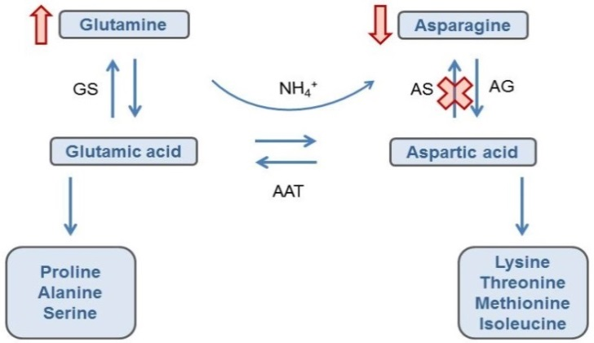

Figure 12: The interrelationship between asparagine and glutamine biosynthesis pathways.
This simplified diagram outlines the metabolic pathways linking the biosynthesis of asparagine and glutamine. The enzyme asparagine synthetase (AS), targeted by RNAi in this Application, converts aspartic acid to asparagine. Aspartic acid can also be converted to glutamic acid and in turn, glutamine. By suppressing the action of AS, the expected result would be a decrease in asparagine and an increase in glutamic acid and glutamine. Other enzymes shown in this pathway include AG – asparaginase, AAT – aspartate aminotransferase, GS – glutamine synthetase.

Although there were major and significant changes in the total asparagine and glutamine levels in the transformed events, the values fall within the tolerance interval and combined published data range indicating these changes are within the natural variation that exists in potato.

5.2.3 Comparison of free amino acid levels
For standard composition analysis of genetically modified foods, a comparison of total amino acid levels between the reference and modified food is performed to determine if there are any unexpected changes in the overall amino acid content. However, amino acids can exist in two forms in an organism, either in free form or bound in peptides, polypeptides or non-peptide molecules. When measuring amino acids, total amino acid levels include both bound and unbound forms and free levels only include the unbound form. In this Application, specific free amino acid levels were also investigated as it is the unbound form of asparagine that contributes to the formation of acrylamide during cooking.

Analysis of the free amino acid levels (Table 18) showed that asparagine has been significantly reduced by 4.1, 4.4, 3.4, 4.4 and 4.6-fold for F10, J3, W8, X17 and Y9 respectively, correlated with increased glutamine levels. There was a minor but significant increase in glutamic acid levels in all transformants but a significant increase in aspartic acid levels was only seen in W8. Again, these results are expected because aspartic acid and glutamic acid can also be converted to other metabolites, such as other amino acids (Figure 12).

Although there are significant differences in free asparagine and glutamine levels between the transformed lines (F10, J3, W8, X17, Y9) and their respective parental lines, the values fall within the natural variation range seen in the reference strains and the ranges presented in the published literature.
Table 18: Summary of free asparagine and glutamine results
Variable | Sample | Mean (mg/100g) |  |  |  |  | Tolerance Interval | Published Range
 |  | F10 | J3 | W8 | X17 | Y9
Asparagine | Control | 235 | 206 | 300 | 331 | 282 | 60-490 | 31-689
 | Transformant | 56.7¹ | 46.8 | 87.8 | 76 | 61.9
Aspartic acid | Control | 55.8 | 69.4 | 40.4 | 42.4 | 41.5 | 13-73 | 6.4-75
 | Transformant | 60.0 | 66.0 | 45.2 | 45.5 | 39.5
Glutamine | Control | 96 | 128 | 139 | 121 | 132 | 16-270 | 44-539
 | Transformant | 169 | 192 | 252 | 207 | 238
Glutamic acid | Control | 55.7 | 66.1 | 40.8 | 55.0 | 57.8 | 10-83 | 45-74
 | Transformant | 65.2 | 67.9 | 51.3 | 61.4 | 65.0
1. Bolded and underlined results indicate those data points that were statistical significant when comparing the control to the transformed line.

5.2.4 Changes in sucrose and reducing sugars
As part of the standard compositional analysis, total carbohydrate and crude fibre levels were analysed and have been presented in Table 15. In this Application however, enzymes involved in the hydrolysis of the carbohydrates starch and sucrose have been targeted for suppression by RNAi thus it would be important to determine the effect on these carbohydrates as well. To achieve this, both sucrose and the end products of the hydrolysis of starch and sucrose, glucose and fructose were analysed. As glucose and fructose contain an aldehyde group that can act as a reducing agent, these sugars are known as reducing sugars.

The data from freshly harvested tubers from the progenitor lines F10 and J3 showed no change in sucrose or reducing sugar levels (Table 19). However, in W8, X17 and Y9, sucrose was significantly higher and reducing sugar levels were significantly lower than their respective parental controls. Although the changes observed in these second generation lines are significant, the values fall within the tolerance interval and published literature range (not shown) indicating the levels are typically found in potatoes. The changes also have no impact on total carbohydrate levels (Table 15). Interestingly, in X17 and Y9, there is an increase in crude fibre levels which may be the result of the excess sucrose. When the plant has sufficient amounts of sucrose, it will produce more stored carbohydrates such as starch and cellulose, which make up the components of crude fibre.

The carbohydrate changes observed in W8, X17 and Y9 compared to that seen in the progenitor lines F10 and J3 highlight which enzymes have been successfully suppressed by RNAi. Firstly, based on the gene transcript data discussed in Section 3.4.6, the two carbohydrate enzymes targeted in the first transformation step may not be effectively silenced. Water dikinase (R1) was not suppressed at all and phosphorylase L (PhL) was shown to be reduced in W8 and Y9 but not X17. Second, as there was no change in sucrose and reducing sugar levels in F10 and J3, this indicates the gene fragments from pSIM1278 are not effectively silencing their target enzymes. Taken together, the change in sucrose and reducing sugar levels observed in W8, X17 and Y9 seem to correlate with the suppression of the vacuolar invertase gene (VInv) alone.

Table 19: Summary of the sucrose and reducing sugar levels in freshly harvested and cold-stored potatoes
 | Time in cold storage | Sample | Mean Sucrose (mg/100g) |  |  |  |  | Mean Reducing Sugars (mg/100g)
 |  |  | F10 | J3 | W8 | X17 | Y9 | F10 | J3 | W8 | X17 | Y9
 | Fresh | Control | 188 | 161 | 241 | 256 | 150 | 185 | 62 | 146 | 86 | 20
 |  | Transformant | 174 | 165 | 395¹ | 326 | 169 | 182 | 49 | 38 | 21 | 7
8-10°C | 3 month | Control | – | – | 148 | – | – | – | – | 483 | – | –
 |  | Transformant | – | – | 651 | – | – | – | – | 122 | – | –
 | 6 month | Control | – | – | 98 | 172 | 192 | – | – | 261 | 229 | 107
 |  | Transformant | – | – | 202 | 298 | 256 | – | – | 116 | 74 | 15
 | 9 month | Control | – | – | 57 | – | – | – | – | 224 | – | –
 |  | Transformant | – | – | 146 | – | – | – | – | 106 | – | –
3°C | 6 month | Control | – | – | 182 | 361 | 162 | – | – | 640 | 889 | 36
 |  | Transformant | – | – | 963 | 901 | 132 | – | – | 92 | 289 | 12
 | 9 month | Control | – | – | 152 | – | – | – | – | 754 | – | –
 |  | Transformant | – | – | 645 | – | – | – | – | 151 | – | –
1. Bolded and underlined results indicate statistical significance when comparing the control to the transformed line.

Comparison of the sugar levels in the tubers kept in cold storage showed the transformed lines W8, X17 and Y9 consistently had higher levels of sucrose and significantly lower levels of reducing sugars compared to the parental controls (Table 19). This pattern of higher sucrose and lower reducing sugars occurred even though the mean sugar levels fluctuated over time within the control and transformed groups. Again, these data correlate well with the RNAi suppression of the vacuolar invertase gene. Although there were significant differences between the levels of sucrose and reducing sugars in the transformed lines compared to their parental controls, the values fall within the natural variation seen in the reference lines and the ranges presented in the published literature.

5.3 Conclusions of the compositional analyses
Detailed compositional analyses were undertaken of transformed lines F10, J3, W8, X17 and Y9 to characterise the intended compositional changes as well as identify any unintended compositional changes. This included analysis of proximates, fibre, vitamins, minerals, total amino acids, free amino acids, sucrose, reducing sugars (fructose and glucose), and glycoalkaloids. The amounts detected were compared to levels found in:

(a) the non-GM parental lines: Russet Burbank, Ranger Russet and Atlantic
(b) reference lines consisting of non-GM commercial and proprietary varieties grown under the same or similar conditions
(c) levels published in the literature.

There were minimal changes to the proximates, fibre, vitamins, minerals and total amino acid levels in the transformed potatoes. There were significant changes observed in the levels of both total and free asparagine and glutamine but this was expected. One of the main aims of the genetic modification in W8, X17, Y9, F10 and J3 was to suppress the asparagine synthetase enzyme (Asn1), in order to decrease the asparagine levels that would in turn lead to an increase in glutamine. Even though the changes were significant, the concentrations reported fell within the natural variation range observed in a variety of potato lines, indicating that these changes are not biologically significant.

Similarly, the level of sucrose in freshly harvested tubers was significantly increased in the W8, X17 and Y9 lines associated with significantly lower levels of reducing sugars.
These results were expected due to the suppression of the vacuolar invertase (VInv) enzyme, involved in regulating sucrose levels. Although these differences were significant, the concentrations reported fell within the natural variation range observed in the reference lines, indicating that these changes are not biologically significant. Minimal changes in sucrose and reducing sugar levels were observed in the progenitor lines associated with minimal suppression of the enzymes targeted in the first transformation step.

In summary, the tubers from W8, X17, Y9, F10 and J3 are compositionally equivalent to tubers from conventional potato varieties. No conclusion could be made in relation to E56 as no compositional data was provided.

6 Nutritional impact
In assessing the safety of a GM food, a key factor is the need to establish the food is nutritionally adequate and will support typical growth and well-being. In most cases, this can be achieved through an understanding of the genetic modification and its consequences, together with an extensive compositional analysis of the food.

If the compositional analysis indicates biologically significant changes to the levels of certain nutrients in the GM food, additional assessment should be undertaken to assess the consequences of the changes and determine whether nutrient intakes are likely to be altered by the introduction of such foods into the food supply. Where a GM food has been shown to be compositionally equivalent to conventional varieties, the evidence to date indicates that feeding studies will add little to the safety assessment and would not be warranted (OECD 2003; Bartholomaeus et al. 2013; Herman and Ekmay 2014).

The transformed lines W8, X17 and Y9 and the progenitor lines E56, F10 and J3 are the result of genetic modifications that have the ultimate intention of reducing blackspot bruising and reducing the potential to produce acrylamide. In addition, W8, X17 and Y9 lines provide resistance to foliar late blight infection. To achieve these outcomes, the genetic modifications resulted in the reduced expression of four endogenous genes and the expression of one novel protein. The extensive compositional analyses of tubers that have been undertaken to demonstrate the nutritional adequacy of potato lines W8, X17, Y9, F10 and J3 indicate they are equivalent in composition to tubers from conventional potato cultivars.

The introduction of food from W8, X17 and Y9 and the progenitor lines F10 and J3 into the food supply is therefore expected to have little nutritional impact and, as such, no additional studies, including animal feeding studies, are required.

7 References
Bartholomaeus A, Parrott W, Bondy G, Walker K (2013) The use of whole food animal studies in the safety assessment of genetically modified crops: Limitations and recommendations. Critical Reviews in Toxicology 43(S2):1–24
Bhaskar PB, Wu L, Busse JS, et al. (2010) Suppression of the vacuolar invertase gene prevents cold-induced sweetening in potato, Plant Physiol 154:939–948
Bushey DF, Bannon GA, Delaney BF, et al. (2014) Characteristics and safety assessment of intractable proteins in genetically modified crops. Regul Toxicol Pharmacol 69:154–170
Carthew RW, Sontheimer EJ (2009) Origins and mechanisms of miRNAs and siRNAs. Cell 136:642–655
CFIA (2015) The biology of Solanum tuberosum (L.) (Potatoes). Canadian Food Inspection Agency, Ontario. http://www.inspection.gc.ca/plants/plants-with-novel-traits/applicants/ directive-94-08/biology-documents/solanum-tuberosum-l-/eng/1330982063974/ 1330982145930. Accessed February 2017
Chawla R, Shakya R, Rommens CM (2012) Tuber-specific silencing of asparagine synthetase-1 reduces the acrylamide-forming potential of potatoes grown in the field without affecting tuber shape and yield. Plant Biotechnol J 10:913–924
Codex (2009) Foods derived from modern biotechnology, 2nd edition. Codex Alimentarius Commission, Joint FAO/WHO Food Standards Programme, Food and Agriculture Organization of the United Nations, Rome. http://www.codexalimentarius.org/standards/ thematic-publications/
Danies G, Small IM, Myers K, Childers R, Fry WE (2013) Phenotypic characterization of recent clonal lineages of Phytophthora infestans in the United States. Plant Disease 97:873–881
Delaney B, Astwood JD, Cunny H, et al. (2008) Evaluation of protein safety in the context of agricultural biotechnology, Food Chem Toxicol 46 (S2): S71-97
FAO (2016) FAOSTAT. Production: Crops. Food and Agriculture Organization of the United Nations, Rome. http://www.fao.org/faostat/en/#data/QC/visualize. Accessed February 2017
FDA (2003) Detection and quantitation of acrylamide in foods, U.S. Food and Drug Administration, Maryland. http://www.fda.gov/Food/FoodborneIllnessContaminants/ChemicalContaminants/ ucm053537.htm. Accessed February 2017
FDA (2013) Guidance for industry: acrylamide in foods. U.S. Food and Drug Administration, Maryland. https://www.fda.gov/Food/GuidanceRegulation/GuidanceDocumentsRegulatoryInformation/ ChemicalContaminantsMetalsNaturalToxinsPesticides/ ucm374524.htm. Accessed February 2017
Forsyth A, Weeks T, Richael C, Duan H (2016) Transcription activator-like effector nucleases (TALEN)-mediated targeted DNA insertion in potato plants. Front Plant Sci 7:e1572
Foster SJ, Park T, Pel M, et al. (2009) Rpi-vnt1.1, a Tm-2(2) homolog from Solanum venturii, confers resistance to potato late blight. Mol Plant Microbe Interact 22:589–600
FSANZ (2013) Response to Heinemann et al on the regulation of GM crops and foods developed using gene silencing. Food Standards Australia New Zealand, Canberra. http://www.foodstandards.gov.au/consumer/gmfood/Pages/Response-to-Heinemann-et-al-on-the-regulation-of-GM-crops-and-foods-developed-using-gene-silencing.aspx. Accessed March 2017.
FSANZ (2016) A1128 – Food derived from reduced acrylamide potential & browning potato line E12. Food Standards Australia New Zealand, Canberra. http://www.foodstandards.gov. au/code/applications/Pages/A1128GMPotatoE12.aspx. Accessed January 2017.
Gao L, Bradeen JM (2016) Contrasting potato foliage and tuber defence mechanisms against the late blight pathogen Phytophthora infestans. PLoS One 11:e0159969
Hawkes JG, Hjerting JP (1960) Some wild potato species from Argentina. Phyton 9:140-146
Herman RA, Ekmay R (2014) Do whole-food animal feeding studies have any value in the safety assessment of GM crops? Regulatory Toxicology and Pharmacology 68:171–174
Hickerson RP, Vlassov AV, Wang Q, et al. (2008) Stability study of unmodified siRNA and relevance to clinical use. Oligonucleotides 18:345-354
Iovene M, Zhang T, Lou Q, Buell CR, Jiang J (2013) Copy number variation in potato - an asexually propagated autotetraploid species. Plant J 75:80–89
Ivashuta SI, Petrick JS, Heisel SE, Zhang Y, Guo L, Reynolds TL, Rice JF, Allen E, Roberts JK (2009) Endogenous small RNAs in grain: semi-quantification and sequence homology to human and animal genes. Food and Chemical Toxicology 47:353–360
JECFA (2011) Safety evaluation of certain contaminants in food. Prepared by the Seventy-second meeting of the Joint FAO/WHO Expert Committee on Food Additives (JECFA), India.
Jones JD, Dangl JL (2006) The plant immune system. Nature 444:323–329
Jones JD, Witek K, Verweij W, et al. (2014) Elevating crop disease resistance with cloned genes. Philos Trans R Soc Lond B Biol Sci 369(1639):e20130087
Kozak M (1989) Circumstances and mechanisms of inhibition of translation by secondary structure in eukaryotic mRNAs. Molecular and Cellular Biology 9(11):5134–5142
Marone D, Russo MA, Laido G, Leonardis AM de, Mastrangelo AM (2013) Plant nucleotide binding site-leucine-rich repeat (NBS-LRR) genes: active guardians in host defence responses. Int J Mol Sci 14:7302–7326
Martinez T, Jimenez AI, Paneda C (2015) Short-interference RNAs: becoming medicines. EXCLI J 14:714-746
McHale L, Tan X, Koehl P, Michelmore RW (2006) Plant NBS-LRR proteins: adaptable guards. Genome Biol 7:e212
Muller-Rober B, La Cognata U, Sonnewald U, Willmitzer L (1994) A truncated version of an ADP-glucose pyrophosphorylase promoter from potato specifies guard cell-selective expression in transgenic plants. Plant Cell 6:601–612
OECD (1997) Consensus document on the biology of Solanum tuberosum subsp. tuberosum (Potato). Organisation for Economic Co-operation and Development, Paris. www.oecd.org/ science/biotrack/46815598.pdf. Accessed January 2017
OECD (2002) Consensus document on compositional considerations for new varieties of potatoes: key food and feed nutrients, anti-nutrients and toxicants. Organisation for Economic Co-operation and Development, Paris. https://www.oecd.org/science/ biotrack/46815167.pdf. Accessed January 2017
OECD (2003) Considerations for the safety assessment of animal feedstuffs derived from genetically modified plants. Organisation for Economic Co-operation and Development, Paris. http://www.oecd.org/officialdocuments/displaydocumentpdf?cote=ENV/JM/MONO (2003)10&doclanguage=en. Accessed January 2017
OECD (2015) Potato (Solanum tuberosum ssp. tuberosum) from Safety Assessment of Foods and Feeds Derived from Transgenic Crops, Vol 1, OECD Publishing, Paris, France.
DOI: http://dx.doi.org/10.1787/9789264180147-en
Richael CM, Kalyaeva M, Chretien RC, et al. (2008) Cytokinin vectors mediate marker-free and backbone-free plant transformation. Transgenic Res 17:905–917
Richael CM, Rommens CM. 2012. Employment of cytokinin vectors for marker-free and backbone-free transformation. Methods Mol Biol 847:3–10
Rommens CM, Yan H, Swords K, Richael C, Ye J (2008) Low-acrylamide French fries and potato chips. Plant Biotechnol J 6:843–853
Rydberg P, Eriksson S, Tareke E, Karlsson P, Ehrenberg L, Tornqvist M (2005) Factors that influence the acrylamide content of heated foods. Adv Exp Med Biol 561:317–328
SASA (2017) The European cultivated potato database. Science and Advice for Scottish Agriculture, Edinburgh. https://www.europotato.org/. Accessed January 2017
Schubert S, Steinhart H, Paschke A (2003) The influence of different potato (Solanum tuberosum) strains and technological processing on allergenicity. Food and Agricultural Immunology 15:41–53
Seppala U, Alenius H, Turjanmaa K, Reunala T, Palosuo T, Kalkkinen N (1999) Identification of patatin as a novel allergen for children with positive skin prick test responses to raw potato. J Allergy Clin Immunol 103:165–171
Seppala U, Majamaa H, Turjanmaa K, et al. (2001) Identification of four novel potato (Solanum tuberosum) allergens belonging to the family of soybean trypsin inhibitors. Allergy 56:619–626
Sowokinos JR (2001) Biochemical and molecular control of cold-induced sweetening in potatoes. Am. J. Pot Res 78:221–236
Stadler RH, Blank I, Varga N, et al. (2002) Food chemistry: acrylamide from Maillard reaction products. Nature 419:449–450
Tareke E, Rydberg P, Karlsson P, Eriksson S, Tornqvist M (2002) Analysis of acrylamide, a carcinogen formed in heated foodstuffs. J Agric Food Chem 50:4998–5006
Title AC, Denzler R, Stoffel M (2015) Uptake and function studies of maternal milk-derived microRNAs. J Biol Chem 290:23680-23691
Ugent D, Peterson LW (1988) Archaeological remains of potato and sweet potato in Peru. CIP Circular 16:1–40
van Haaren MJ, Sedee NJ, Boer HA de, Schilperoort RA, Hooykaas PJ (1989) Mutational analysis of the conserved domains of a T-region border repeat of Agrobacterium tumefaciens. Plant Mol Biol 13:523–531
Visser RG, Stolte A, Jacobsen E (1991) Expression of a chimaeric granule-bound starch synthase-GUS gene in transgenic potato plants. Plant Mol Biol 17:691–699
Wesley SV, Helliwell CA, Smith NA, et al. (2001) Construct design for efficient, effective and high-throughput gene silencing in plants. Plant J 27:581–590
Xu X, Pan S, Cheng S, et al. (2011) Genome sequence and analysis of the tuber crop potato. Nature 475:189–195
Zhu X, Richael C, Chamberlain P, et al. (2014) Vacuolar invertase gene silencing in potato (Solanum tuberosum L.) improves processing quality by decreasing the frequency of sugar-end defects. PLoS One 9:e93381

http://www.innatepotatoes.com/
http://potatoassociation.org/industry/varieties/russet-potato-varieties/ranger-russet-solanum-tuberosum
www.ncbi.nlm.nih.gov/nuccore/AF234297.1
http://solanaceae.plantbiology.msu.edu/cgi-bin/gbrowse/potato/
https://tinyurl.com/guu7r54
https://tinyurl.com/jdwv54f
www.uniprot.org/uniprot/M1BH99
http://www.uniprot.org/uniprot/M1C564
www.allergenonline.org
www.ncbi.nlm.nih.gov/protein/18542113
www.ncbi.nlm.nih.gov/protein/AAL75450
Intractable proteins are those that are extremely difficult to isolate and purify. Without the ability to obtain a high amount of purified product, protein characterisation studies cannot be performed.
Spreader plants are pathogen susceptible plants that are used to inoculate and allow the movement of a pathogen throughout the field trial area
web.expasy.org/peptide_cutter/

